**DESIGN OF BLENDED WING AIRCRAFT WITH TWIN FUSELAGE**

**ASB4341 - DESIGN PROJECT-1 REPORT**

***Submitted by***

**JEFRAN CALVIN J (19103018)**

**SANJU MALLICK (19103017)**

**MURALI KRISHNA Y (19103014)**

*In partial fulfilment for the award of the degree*

*Of*

**BACHELOR OF TECHNOLOGY**

***In***

**AEROSPACE ENGINEERING**



**SCHOOL OF AERONAUTICAL SCIENCES**

**HINDUSTAN INSTITUTE OF TECHNOLOGY AND SCIENCE**

**PADUR, CHENNAI - 603 103**

**APRIL 2022**



**BONAFIDE CERTIFICATE**

Certified that this project report titled **“DESIGN OF TWIN FUSELAGE BLENDED WING AIRCRAFT”** is the bonafide work of **JEFRAN CALVIN J (19103018), SANJU MALLICK (19103017), MURALIKRISHNAN Y (19103014)** who carried out the project work under my supervision. Certified further that to the best of my knowledge the work reported here does not form part of any other project / research work on the basis of which a degree or award was conferred on an earlier occasion on this or any other candidate.

**Dr. Parthasarathy Vasanthakumar Mr. J. Jensin Joshua**

Professor & Head of the Department Assistant Professor (S.S)

School of Aeronautical Sciences School of Aeronautical Sciences

HITS, Chennai 603 103 HITS, Chennai 603 103

The Project Viva-Voce Examination is held on _______________

**INTERNAL EXAMINER EXTERNAL EXAMINER**

**ACKNOWLEDGEMENT**

It’s my pleasure to thank our chairperson **Dr. Mrs. Elizabeth Verghese** and Management of Hindustan Institute of Technology and Science, for providing me with good, pleasing and safe environment in our college which helped me a lot to carry on with our project.

We have taken efforts in this project. However, it would not have been possible without the kind support and help of many individuals and the institution. We would like to extend our sincere thanks to all of them. We would extend our heart full and deepest thanks to Prof **Dr.** **PARTHASARTHY VASANTHAKUMAR**,HOD Aerospace Department for giving us his kind and able support.

At this occasion we must emphasize that this “DESIGN PROJECT - 1” would have not been possible without the highly informative and valuable guidance by our faculty **MR JENSIN JOSHUA.** We thank him for his guidance and correction of various documents and calculation with attention and care. He has taken pain to go through the project and make necessary corrections when needed. We have the great pleasure in expressing our sincere whole hearted thanks to him

Last but not least wish we avail ourselves of this opportunity, express a sense of gratitude, appreciations and love to our friends, our classmates, our well-wisher and beloved parents for their manual support, strength, help and for everything in developing the project an people who have willingly helped us out with their abilities for their kind co operations to the completion of our project work.

**Abstract**

The need for defence aircrafts have increased drastically in years. The world expects a faster and stealthy mode of bomber. A Commercial aircraft cannot give an exclusive and luxurious way of transport thus, we need a Blended wing which is a bomber.

The aim of this project is to design and conceptualize a Blended Wing Twin Fuselage that can cater to a wide range of defence related queries. The project involves the design of a bomber that can accommodate 2 pilots at full seating layout, providing the amenities and high level of comfort while incorporating the design specifications and performance parameters of a long-range defence aircraft. The aircraft allows for long range transport with better efficiency and reduced fuel consumption and noise levels owing to a state-of-the-art engine and design features.

An efficient mission profile which comes as a result of a well-engineered aircraft is expected in the market. The input to the concept Mission profile is a flight profile of the aircraft defined by the customer. Wing profile and vertical tail configurations have direct impact on lift, drag, stability, performance and manoeuvrability of the aircraft. A propulsion system directly influences the performance of the aircraft. By combining the wing profile and the propulsion system, two important parameters, known as wing loading and thrust to weight ratio can be calculated.

The air foil used in this aircraft gives high lift characteristics and they have superior take-off and landing performances.

**Keywords:***Twin Fuselage, Blended Wing, Long range, Bomber, Mission profile, Manoeuvrability, Wing loading, Thrust – Weight ratio, Supercritical air foil, Lift characteristics*

**Table of Contents**

|  |  |  |
| --- | --- | --- |
| **CHAPTER NO.** | **TITLE** | **PAGE NO** |
|  | ABSTRACT | iv |
|  | LIST OF TABLES  LIST OF FIGURES & GRAPHS  LIST OF SYMBOLS AND ABBREVIATION | vii  viii  xiii |
| 01. | INTRODUCTION TO DESIGN | 1 |
| 02. | INTRODUCTION TO BLENDED WING AND TWIN FUSELAGE AIRCRAFTS | 10 |
| 03. | PREPARATION OF COMPARATIVE DATA SHEET OF DIFFERENT AIRCRAFTS | 24 |
| 04. | PREPARATION OF COMPARATIVE GRAPHS | 27 |
| 05. | SELECTION OF TENTATIVE DESIGN PARAMETERS | 34 |
| 06. | FLIGHT PROFILE AND WEIGHT ESTIMATION | 36 |
| 07. | AEROFOIL AND WING SELECTION | 46 |
| 08. | TAIL PLANE SELECTION | 76 |
| 09. | ENGINE SELECTION | 82 |
| 10. | LANDING GEAR SELECTION | 89 |
| 11. | FUSELAGE SELECTION | 94 |
| 12. | LIFT AND DRAG ESTIMATION | 97 |
| 13. | PERFORMANCE CALCULATIONS | 101 |
| 14. | 3-VIEW DIAGRAM | 104 |
|  | CONCLUSION | 106 |
|  | REFERENCE | 107 |

**List of Tables**

|  |  |  |
| --- | --- | --- |
| **TABLE NO.** | **TITLE** | **PAGE NO.** |
| 1.1 | Design process breakdown | 8 |
| 3.1 | General Characteristics of Aircrafts | 24 |
| 3.2 | Weight Configurations of Aircrafts | 25 |
| 3.3 | Performance of Aircraft | 26 |
| 6.1 | Fuel –Fraction for Several Mission Phases | 39 |
| 6.2 | Mission Cruise and loiter parameter for Several Phases | 39 |
| 6.3 | WE Values | 44 |
| 6.4 | Weight Parameters | 45 |
| 7.1 | Root Air foil Data | 60 |
| 7.2 | Lieback LA2573 A Data | 61 |
| 7.3 | Tip Airfoil Data | 64 |
| 7.4 | Eppler 395 Data | 65 |
| 10.1 | Engine Data | 85 |
| 10.2 | Engine Performance Data | 86 |
| 11.1 | Calculated Lift and Drag Data | 99 |
| 12.1 | Performance Parameters | 101 |

**List of Figures**

|  |  |  |
| --- | --- | --- |
| **FIGURE NO.** | **CONTENTS** | **PAGE NO.** |
| 1.1 | Design Process flow chart | 6 |
| 2.1 | Lift vs weight of blended wing | 11 |
| 2.2 | Northrop YB-49 | 11 |
| 2.3 | Northrop B-2 Stealth Bomber | 13 |
| 2.4 | Lockheed SR 71 Blackbird | 14 |
| 2.5 | Boeing X-48 B | 16 |
| 2.6 | Lockheed A-12 | 17 |
| 2.7 | Twin fuselage advantages | 18 |
| 2.8 | North American F-82 Twin Mustang | 19 |
| 2.9 | Belyayev DB-LK | 20 |
| 2.10 | Blériot 125 | 21 |
| 2.11 | Savoia-Marchetti SM.92 | 22 |
| 2.12 | Tupolev ANT-22 | 22 |
| 4.1 | Graph: Cruising speed Vs Crew | 27 |
| 4.2 | Graph: Cruising speed Vs Length | 28 |
| 4.3 | Graph: Cruising speed Vs Height | 28 |
| 4.4 | Graph: Cruising speed Vs Wing Area | 29 |
| 4.5 | Graph: Cruising speed Vs Wing Span | 29 |
| 4.6 | Graph: Cruising speed Vs Aspect Ratio | 30 |
| 4.7 | Graph: Cruising speed Vs Empty Weight | 30 |
| 4.8 | Graph: Cruising speed Vs Maximum Take-Off Weight | 31 |
| 4.9 | Graph: Cruising speed Vs Gross Weight | 31 |
| 4.10 | Graph: Cruising speed Vs Maximum Speed | 32 |
| 4.11 | Graph: Cruising speed Vs Service Ceiling | 32 |
| 4.12 | Graph: Cruising speed Vs Range | 33 |
| 4.13 | Graph: Cruising speed Vs Wing Loading | 33 |
| 6.1 | Flight Profile | 36 |
| 7.1 | Monoplane | 46 |
| 7.2 | Biplane | 47 |
| 7.3 | Triplane | 47 |
| 7.4 | Cantilever Support | 48 |
| 7.5 | Semi-Cantilever Support | 49 |
| 7.6 | High Wing | 50 |
| 7.7 | Mid Wing | 50 |
| 7.8 | Low Wing | 51 |
| 7.9 | Shoulder Wing | 51 |
| 7.10 | Parasol Wing | 52 |
| 7.11 | Blended Wing | 52 |
| 7.12 | Rectangle Wing | 54 |
| 7.13 | Elliptical Wing | 54 |
| 7.14 | Tapered Wing | 55 |
| 7.15 | Swept Forward Wing | 55 |
| 7.16 | Swept Backward Wing | 56 |
| 7.17 | Types of Delta Wing | 56 |
| 7.18 | Anhedral Wing | 58 |
| 7.19 | Straight Wing | 58 |
| 7.20 | Dihedral Wing | 59 |
| 7.21 | Liebeck LA2573 A Air foil | 61 |
| 7.22 | Alpha Vs Coefficient of Lift | 62 |
| 7.23 | Coefficient of Lift Vs Coefficient of Drag | 62 |
| 7.24 | Alpha Vs Ratio of Coefficient of Lift and Drag | 63 |
| 7.25 | Alpha Vs Coefficient of Moment | 63 |
| 7.26 | Eppler 395 | 64 |
| 7.27 | Alpha Vs Coefficient of Lift | 66 |
| 7.28 | Coefficient of Lift Vs Coefficient of Drag | 66 |
| 7.29 | Alpha Vs Ratio of Coefficient of Lift and Drag | 67 |
| 7.30 | Alpha Vs Coefficient of Moment | 67 |
| 7.31 | Air foil Outline | 70 |
| 7.32 | Isometric View | 71 |
| 7.33 | Top View | 71 |
| 7.34 | Side View | 72 |
| 7.35 | Pressure Distribution in Air foil with Vectors for Liebeck LA2537 A | 73 |
| 7.36 | Pressure Distribution in Air foil for Liebeck LA2537 A | 73 |
| 7.37 | Pressure Distribution in Air foil with Vectors for Eppler 395 | 74 |
| 7.38 | Pressure Distribution in Air foil for Eppler 395 | 74 |
| 8.1 | Conventional Tail | 75 |
| 8.2 | T - Tail | 76 |
| 8.3 | V – Tail | 76 |
| 8.4 | Inverted V - Tail | 77 |
| 8.5 | Cruciform Tail | 77 |
| 8.6 | Tailless | 78 |
| 8.7 | Y-Tail | 78 |
| 8.8 | H-Tail | 79 |
| 8.9 | Twin Boom | 79 |
| 9.1 | Reciprocating Engine | 81 |
| 9.2 | Turbojet Engine | 82 |
| 9.3 | Turbofan Engine | 82 |
| 9.4 | Turboprop Engine | 83 |
| 9.5 | Ramjet Engine | 83 |
| 9.6 | Scramjet Engine | 84 |
| 9.7 | Pulsejet Engine | 84 |
| 9.8 | Pratt & Whitney J58Engine | 86 |
| 9.9 | Working of the Pratt & Whitney J58Engine | 87 |
| 10.1 | Fixed Landing Gear | 88 |
| 10.2 | Retractable Landing Gear | 89 |
| 10.3 | Single Wheel Landing Gear | 90 |
| 10.4 | Bicycle | 90 |
| 10.4 | Tricycle | 91 |
| 10.6 | Quadricycle | 91 |
| 10.7 | Multi-bogey | 92 |
| 9.1 | Monocoque | 93 |
| 9.2 | Semi-Monocoque | 94 |
| 9.3 | Geodesic Truss | 96 |
| 14.1 | Top View | 102 |
| 14.2 | Front View | 102 |
| 14.3 | Left-Side View | 103 |

**Symbols and Abbreviation**

* A.R - Aspect Ratio
* B - Wing span(m)
* C - Chord of the Aerofoil (m)
* CRoot - Chord at Root (m)
* CTip - Chord at Tip (m)
* Cd - Drag Co-efficient
* CD,0 - Zero lift Drag co-efficient
* CP - Specific fuel consumption (lbs / hp / hr)
* CL - Lift Co-efficient
* D - Drag(N)
* E - Endurance (hr)
* e - Oswald efficiency factor
* L - Lift (N)
* (L/D)Loiter - Lift-to-drag ratio at loiter
* (L/D)Cruise - Lift-to-drag ratio at cruise
* M - Mach number of aircraft
* MFF - Mission fuel fraction
* R - Range (km)
* Re - Reynolds number
* S - Wing area (m2)
* SRef - Reference surface area
* SWet - Wetted surface area
* Sa - Approach distance (m)
* Sf - Flare distance (m)
* Sfr - Freeroll distance (m)
* S.C - Service ceiling
* A.C - Absolute ceiling
* T - Thrust (N)
* TCruise - Thrust at cruise (N)
* TTake-off - Thrust at take-off (N)
* (T/W)Loiter - The thrust-to-weight ratio at Loiter
* (T/W)Cruise - The thrust-to-weight ratio at cruise
* (T/W)Take-off - The thrust-to-weight ratio at take-off
* VCruise - velocity at cruise (m/s)
* VStall - velocity at stall (m/s)
* Vt - Velocity at touch down (m/s)
* WCrew - Crew weight (kg)
* Wempty - Empty weight of the aircraft (kg)
* WFuel - Weight of fuel (kg)
* WPayload - Payload of the aircraft (kg)
* W0 - Overall weight (kg)
* W/S - Wing loading (kg/m2)
* ρ - Density of air (kg/m3)
* μ - Dynamic viscosity (Ns/m2)
* λ - Tapered ratio
* R/C - Rate of Climb
* η - Kinematic viscosity (m2/s)

# **CHAPTER 1**

**INTRODUCTION TO DESIGN**

# **1.1 INTRODUCTION TO DESIGN**

Modern aircraft are a complex combination of aerodynamic performance, lightweight durable structures and advanced systems engineering. Air passengers demand more comfort and more environmentally friendly aircraft. Hence many technical challenges need to be balanced for an aircraft to economically achieve its design specification. Aircraft design is a complex and laborious undertaking with a number of factors and details that are required to be checked to obtain optimum the final envisioned product. The design process begins from scratch and involves a number of calculations, logistic planning, design and real-world considerations, and a level head to meet any hurdle head on.

***Aerodynamics*** is the study of how air flows around an airplane. In order for an airplane to fly at all, air must flow over and under it’s every airplane goes through many changes in design before it is finally built in a factory. These steps between the first ideas for an airplane and the time when it is actually flown make up the design process. Along the way, engineers think about four main areas of aeronautics: *Aerodynamics*, *Propulsion*, *Structures and Materials*, and *Stability and Control*.

***Wings***. The more aerodynamic, or streamlined the airplane is, the less resistance it has against the air. If air can move around the airplane easier, the airplane's engines have less work to do. This means the engines do not have to be as big or eat up as much fuel which makes the airplane more lightweight and easier to fly. Engineers have to think about what type of airplane they are designing because certain airplanes need to be aerodynamic in certain ways. For example, fighter jets maneuver and turn quickly and fly faster than sound (supersonic flight) over short distances. Most passenger airplanes, on the other hand, fly below the speed of sound (subsonic flight) for long periods of time.

***Propulsion*** is the study of what kind of engine and power an airplane needs. An airplane needs to have the right kind of engine for the kind of job that it has. A passenger jet carries many passengers and a lot of heavy cargo over long distances so its engines need to use fuel very efficiently. Engineers are also trying to make airplane engines quieter so they do not bother the passengers onboard or the neighborhoods they are flying over. Another important concern is making the exhaust cleaner and more environmentally friendly. Just like automobiles, airplane exhaust contains chemicals that can damage the earth's environment.

***Structures and Materials*** is the study of how strong the airplane is and what materials will be used to build it. It is really important for an airplane to be as lightweight as possible. The less weight an airplane has, the less work the engines have to do and the farther it can fly. It is tough designing an airplane that is lightweight and strong at the same time. In the past, airplanes were usually made out of lightweight metals like aluminium, but today a lot of engineers are thinking about using *composites* in their designs. Composites look and feel like plastic but are stronger than most metals. Engineers also need to make sure that airplanes not only fly well but are also easy to build and maintain.

***Stability and Control*** is the study of how an airplane handles and interacts to pilot input and feed. Pilots in the cockpit have a lot of data to read from the airplane's computers or displays. Some of this information could include the airplane's speed, altitude, direction, and fuel levels as well as upcoming weather conditions and other instructions from ground control. The pilot needs to be able to process the correct data quickly, to think about what kind of action needs to be taken, and to react in an appropriate way. Meanwhile, the airplane should display information to the pilot in an easy-to-read and easy-to-understand way. The controls in the cockpit should be within easy reach and just where the pilot expects them to be. It is also important that the airplane responds quickly and accurately to the pilot's instructions and manoeuvres.

When you look at aircraft, it is easy to observe that they have a number of common features: wings, a tail with vertical and horizontal wing sections, engines to propel them through the air, and a fuselage to carry passengers or cargo. If, however, you take a more critical look beyond the gross features, you also can see subtle, and sometimes not so subtle, differences. This is where design comes into play. Each and every aircraft is built for a specific task, and the design is worked around the requirement and need of the aircraft. The design is modelled about the aircraft role and type and not the other way around. Thus, this is why airplanes differ from each other and are conceptualized differently. Aircrafts that fall in the same category may have similar specifications and performance parameters, albeit with a few design changes.

Design is a pivotal part of any operation. Without a fixed idea or knowledge of required aircraft, it is not possible to conceive the end product. Airplane design is both an art and a science. In that respect it is difficult to learn by reading a book; rather, it must be experienced and practiced. However, we can offer the following definition and then attempt to explain it. Airplane design is the intellectual engineering process of creating on paper (or on a computer screen) a flying machine to (1) meet certain specifications and requirements established by potential users (or as perceived by the manufacturer) and/or (2) pioneer innovative, new ideas and technology. An example of the former is the design of most commercial transports, starting at least with the Douglas DC-1 in 1932, which was designed to meet or exceed various specifications by an airplane company. (The airline was TWA, named Transcontinental and Western Air at that time.) An example of the latter is the design of the rocket-powered Bell X1, the first airplane to exceed the speed of sound in level or climbing flight (October 14, 1947). The design process is indeed an intellectual activity, but a rather special one that is tempered by good intuition developed via experience, by attention paid to successful airplane designs that have been used in the past, and by (generally proprietary) design procedures and databases (handbooks, etc) that are a part of every airplane manufacturer.

**1.1 DEFINING A NEW DESIGN**

The design of an aircraft draws on a number of basic areas of aerospace engineering. These include aerodynamics, propulsion, light-weight structures and control. Each of these areas involves parameters that govern the size, shape, weight and performance of an aircraft. Although we generally try to seek optimum in all these aspects, with an aircraft, this is practically impossible to achieve. The reason is that in many cases, optimizing one characteristic degrades another.

There are many performance aspects that can be specified by the mission requirements. These include:

* The aircraft purpose or mission profile
* The type(s) and amount of payload
* The cruise and maximum speeds
* The normal cruise altitude
* The range or radius with normal payload
* The endurance
* The take-off distance at the maximum weight
* The purchase cost

***1.1.1 Aircraft Purpose***

The starting point of any new aircraft is to clearly identify its purpose. With this, it is often possible to place a design into a general category. Such categories include combat aircraft, passenger or cargo transports, and general aviation aircraft. These may also be further refined into subcategories based on particular design objectives such as range (short or long), take-off or landing distances, maximum speed, etc. The process of categorizing is useful in identifying any existing aircraft that might be used in making comparisons to a proposed design. With modern military aircraft, the purpose for a new aircraft generally comes from a military program office. For example, the mission specifications for the X-29 pictured in figure 1.1 came from a 1977 request for proposals from the U.S. Air Force Flight Dynamics Laboratory in which they were seeking a research aircraft that would explore the forward swept wing concept and validate studies that indicated such a design could provide better control and lift qualities in extreme manoeuvres. With modern commercial aircraft, a proposal for a new design usually comes as the response to internal studies that aim to project future market needs. For example, the specifications for the Boeing commercial aircraft (B-777) were based on the interest of commercial airlines to have a twin-engine aircraft with a payload and range in between those of the existing B-767 and B-747 aircraft. Since it is not usually possible to optimize all of the performance aspects in an aircraft, defining the purpose leads the way in setting which of these aspects will be the “design drivers.” For example, with the B-777, two of the prominent design drivers were range and payload.

* 1. **DESIGN MOTIVATION**

Fundamentally, an aircraft is a structure. Aircraft designers design structures. The structures are shaped to give them desired aerodynamic characteristics, and the materials and structures of their engines are chosen and shaped so they can provide needed thrust. Even seats, control sticks, and windows are structures, all of which must be designed for optimum performance. Designing aircraft structures is particularly challenging, because their weight must be kept to a minimum. There is always a trade-off between structural strength and weight. A good aircraft structure is one which provides all the strength and rigidity to allow the aircraft to meet all its design requirements, but which weighs no more than necessary. Any excess structural weight often makes the aircraft cost more to build and almost always makes it cost more to operate. As with small excesses of aircraft drag, a small percentage of total aircraft weight used for structure instead of payload can make the difference between a profitable airliner or successful tactical fighter and a failure. Designing aircraft structures involves determining the loads on the structure, planning the general shape and layout, choosing materials, and then shaping, sizing and optimizing its many components to give every part just enough strength without excess weight. Since aircraft structures have relatively low densities, much of their interiors are typically empty space which in the complete aircraft is filled with equipment, payload, and fuel. Careful layout of the aircraft structure ensures structural components are placed within the interior of the structure so they carry the required loads efficiently and do not interfere with placement of other components and payload within the space. Choice of materials for the structure can profoundly influence weight, cost, and manufacturing difficulty. The extreme complexity of modern aircraft structures makes optimal sizing of individual components particularly challenging. An understanding of basic structural concepts and techniques for designing efficient structures is essential to every aircraft design

* 1. **DESIGN PROCESS**

The process of designing an aircraft and taking it to the point of a flight test article consists of a sequence of steps, as illustrated in the figure. It starts by identifying a need or capability for a new aircraft that is brought about by (1) a perceived market potential and (2) technological advances made through research and development. The former will include a market-share forecast, which attempts to examine factors that might impact future sales of a new design. These factors include the need for a new design of a specific size and performance, the number of competing designs, and the commonality of features with existing aircraft. As a rule, a new design with competitive performance and cost will have an equal share of new sales with existing competitors. The needs and capabilities of a new aircraft that are determined in a market survey go to define the mission requirements for a conceptual aircraft. These are compiled in the form of a design proposal that includes (1) the motivation for initiating a new design and (2) the “technology readiness” of new technology for incorporation into a new design. It is essential that the mission requirements be defined before the design can be started. Based on these, the most important performance aspects or “design drivers” can be identified and optimized above all others. Following the design proposal, the next step is to produce a conceptual design. The conceptual design develops the first general size and configuration for a new aircraft. It involves the estimates of the weights and the choice of aerodynamic characteristics that will be best suited to the mission requirements stated in the design proposal. The conceptual design is driven by the mission requirements, which are set in the design proposal. In some cases, these may not be attainable so that the requirement may need to be relaxed in one or more areas. This is shown in the iterative loop in the flow chart. When the mission requirements are satisfied, the design moves to the next phase, which is the preliminary design.

No

Requirements Satisfied

Yes

Stop

Final Evaluation

Go

Research, Development and Market Analysis

Mission Requirements

Conceptual Design

Preliminary Design

Detailed Design

Test Article Fabrication

Flight Test

No

Requirements Satisfied

Yes

Stop

Final Evaluation

Go

Research, Development and Market Analysis

Mission Requirements

Conceptual Design

Preliminary Design

Detailed Design

Test Article Fabrication

Flight Test

*Figure. 1.1 Design Process flow chart*

**Conceptual design**

This article deals with the steps involved in the conceptual design of an aircraft. It is broken down in to several elements, which are followed in order. These consist of:

1. Literature survey
2. Preliminary data acquisition
3. Estimation of aircraft weight
   * + 1. Maximum take-off weight
       2. Empty weight of the aircraft
       3. Weight of the fuel
       4. Fuel tank capacity
4. Estimation of critical performance parameters
   * + 1. Wing area
       2. Lift and drag coefficients
       3. Wing loading
       4. Power loading
       5. Thrust to weight ratio
5. Engine selection
6. Performance curves
7. 3 View diagrams
   1. **DESIGN PROCESS BREAKDOWN**

*Table 1.1 (Design Process Breakdown)*

|  |  |
| --- | --- |
| • **Conceptual Design:**   * Competing concepts evaluated * Performance goals established * Preferred concept selected | What drives the design?  Will it work/meet requirement?  What does it look like? |
| • **Preliminary Design:**   * Refined sizing of preferred concept tests * Design examined data/establish parameters * Some changes allowed | Do serious wind tunnel tests  Make actual cost estimate |
| • **Detail Design:**   * Final detail design * Drawings released * Detailed performance * Only “tweaking” of design allowed | Certification process  Component/systems tests  Manufacturing  Flight control system design |

**CHAPTER 2**

**INTRODUCTION TO BLENDED WING AND TWIN FUSELAGE AIRCRAFTS**

**2.1 Introduction:**

A Blended Wing is usually used for when high lift is needed and Twin fuselage inside a blended wing could account in extra cargo and passenger facilities.

**2.2 Objectives:**

* Blended wing with twin fuselage aircraft
* Aerodynamic Design
* Better Endurance
* Low fuel needed because of high lift

**2.3 Blended Wing Aircrafts:**

2.3.1 Applications of Blended wings in an aircraft:

1. high fuel economy along with large payload
2. quieter & cleaner operation
3. It is expected that BWB aircraft would improve lift to drag ratio by 50 % and fuel  
   efficiency by 20 to 25 % in comparison to conventional configuration
4. BWB passenger configurations possess three serious advantages such as high L/D ratio due to a decreased relative wetted area, favourable load distribution along the span and  
   possible engine noise shielding.
5. BWB offers a reduction in operating costs while improving an aerodynamic performance and flexibility for both passenger and cargo mission.
6. Flexible for cargo designs.

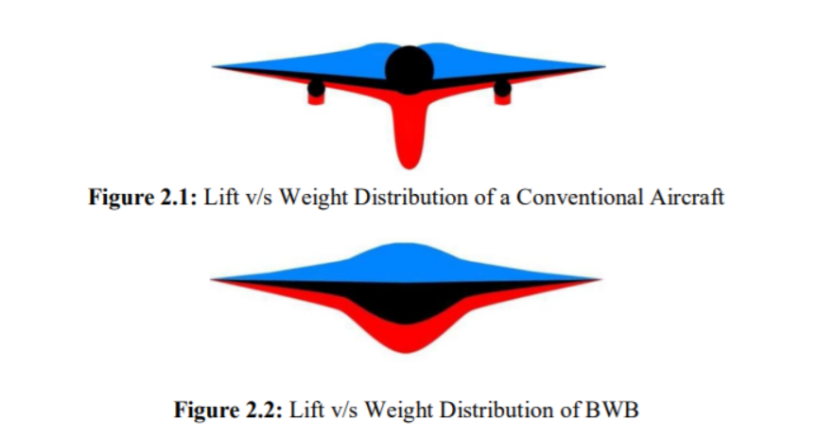

*Figure 2.1 LIFT VS WEIGHT OF BLENDED WING*

**2.4 Study of different types of Blended Wing aircrafts:**

**2.4.1 Northrop YB-49:**

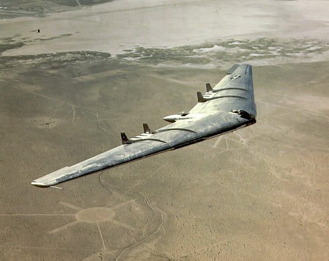

*Figure 2.2 Northrop YB-49*

The Northrop YB-49 was a purely flying wing jet powered heavy bomber aircraft developed by Northrop Corporation in 1947. Although this aircraft was unsuccessful, but it laid the foundation for the development of B-2 stealth fighter.

With the XB-35 program seriously behind schedule by 1944, and the end of piston-engine combat aircraft in sight, the production contract for this propeller-driven type was cancelled in May of that year. Nevertheless, the Flying Wing design was still sufficiently interesting to the Air Force that work was continued on testing a single YB-35A production aircraft.

Among the aircraft later completed were two airframes that the Air Force ordered be fitted with jet propulsion and designated as YB-49s. The first of these new YB-49 jet-powered aircraft flew on 22 October 1947 (from Northrop airfield in Hawthorne, CA) and immediately proved more promising than its piston engine counterpart. The YB-49 set an unofficial endurance record of staying continually above 40,000 ft (12,200 m) for 6.5 hours.

The second YB-49 was lost on 5 June 1948, killing its pilot, Major Daniel Forbes (for whom Forbes Air Force Base was named), co-pilot Captain Glen Edwards (for whom Edwards Air Force Base is named), and three other crew members, one of whom, 1st Lieutenant Edward Lee Swindell, was a crew member on the Boeing B-29 that assisted Chuck Yeager in breaking the sound barrier in the Bell X-1 aircraft.

Their aircraft suffered structural failure, with both outer wing sections becoming detached from the centre section. Speculation at the time was that the YB-49 was lost due to excessive pullout loads imposed on the heavy airframe when a scheduled flight test of the large bomber's stall recovery resulted in a sudden and dramatic high-speed, nose-over dive. The post-stall high-speed dive resulted from the clean, low-drag, all-wing design, which gave the YB-49 a rapid speed increase in any type of dive. Fellow YB-49 test pilot Robert Cardenas later claimed that the YB-49 rotated backwards in stall, and that he warned Edwards about it. Jack Northrop later countered that such a behaviour was impossible for the all-wing design.

During flight tests in the 1940s, it was noticed that the aircraft had a small radar cross-section, due to its flying wing design. Decades later, this stealthy detail would prove crucial to the design of Northrop Grumman's advanced, all-wing B-2 Bomber

**2.4.2 Northrop B-2 Stealth Bomber:**

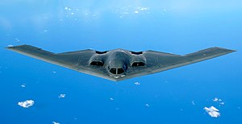

*Figure 2.3 Northrop B-2 Stealth Bomber*

The B-2 spirit, also known as stealth bomber was developed in 1989 by Northrop Grumman Corporation to have a less exposable cross section to radar. The B-2 design falls between classic flying wing and the BWB concept. It is usually classified as a flying wing, as the protruding body sections are not much larger than the underlying wing shape structure. B-2 is revolutionary from an aeronautics perspective: being efficient can cover long ranges without refuelling. It does not have any of the standard stabilizing systems, but flying qualities matches very well with conventional aircraft.

In order to make the B-2 more effective than previous bombers, many advanced and modern avionics systems were integrated into its design; these have been modified and improved following a switch to conventional warfare missions. One system is the low probability of intercept AN/APQ-181 multi-mode radar, a fully digital navigation system that is integrated with terrain-following radar and Global Positioning System (GPS) guidance, NAS-26 Astro-inertial navigation system (first such system tested on the Northrop SM-62 Snark cruise missile) and a Defensive Management System (DMS) to inform the flight crew of possible threats. The onboard DMS is capable of automatically assessing the detection capabilities of identified threats and indicated targets.

For safety and fault-detection purposes, an on-board test system is linked with the majority of avionics on the B-2 to continuously monitor the performance and status of thousands of components and consumables; it also provides post-mission servicing instructions for ground crews. In 2008, many of the 136 standalone distributed computers on board the B-2, including the primary flight management computer, were being replaced by a single integrated system. The avionics are controlled by 13 EMP-resistant MIL-STD-1750A computers, which are interconnected through 26 MIL-STD-1553B-busses; other system elements are connected via optical fibre.

To address the inherent flight instability of a flying wing aircraft, the B-2 uses a complex quadruplex computer-controlled fly-by-wire flight control system that can automatically manipulate flight surfaces and settings without direct pilot inputs in order to maintain aircraft stability. The flight computer receives information on external conditions such as the aircraft's current air speed and angle of attack via pitot-static sensing plates, as opposed to traditional pitot tubes which would impair the aircraft's stealth capabilities. The flight actuation system incorporates both hydraulic and electrical servo actuated components, and it was designed with a high level of redundancy and fault-diagnostic capabilities.

The B-2's low-observable, or "stealth", characteristics enable the undetected penetration of sophisticated anti-aircraft defences and to attack even heavily defended targets. This stealth comes from a combination of reduced acoustic, infrared, visual and radar signatures (multi-spectral camouflage) to evade the various detection systems that could be used to detect and be used to direct attacks against an aircraft. The B-2's stealth enables the reduction of supporting aircraft that are required to provide air cover, Suppression of Enemy Air Defences and electronic countermeasures, making the bomber a "force multiplier".

**2.4.3 Lockheed SR 71 Blackbird:**

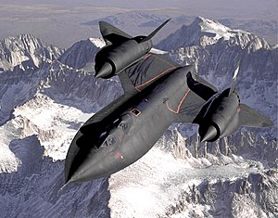

*Figure 2.4 Lockheed SR 71 Blackbird*

The **Lockheed SR-71** "**Blackbird**" is a long-range, high-altitude, Mach 3+ strategic reconnaissance aircraft developed and manufactured by the American aerospace company Lockheed Corporation.

The SR-71 was designed for flight at over Mach 3 with a flight crew of two in tandem cockpits, with the pilot in the forward cockpit and the reconnaissance systems officer operating the surveillance systems and equipment from the rear cockpit, and directing navigation on the mission flight path. The SR-71 was designed to minimize its radar cross-section, an early attempt at stealth design. Finished aircraft were painted a dark blue, almost black, to increase the emission of internal heat and to act as camouflage against the night sky.

On most aircraft, the use of titanium was limited by the costs involved; it was generally used only in components exposed to the highest temperatures, such as exhaust fairings and the leading edges of wings. On the SR-71, titanium was used for 85% of the structure, with much of the rest polymer composite materials. To control costs, Lockheed used a more easily worked titanium alloy which softened at a lower temperature. The challenges posed led Lockheed to develop new fabrication methods, which have since been used in the manufacture of other aircraft. Lockheed found that washing welded titanium requires distilled water, as the chlorine present in tap water is corrosive; cadmium-plated tools could not be used, as they also caused corrosion. Metallurgical contamination was another problem; at one point, 80% of the delivered titanium for manufacture was rejected on these grounds.

The SR-71 was powered by two Pratt & Whitney J58 (company designation JT11D-20) axial-flow turbojet engines. The J58 was a considerable innovation of the era, capable of producing a static thrust of 32,500 lbf (145 kN). The engine was most efficient around Mach 3.2, the Blackbird's typical cruising speed. At take-off, the afterburner provided 26% of the thrust. This proportion increased progressively with speed until the afterburner provided all the thrust at about Mach 3

**2.4.4 Boeing X-48 B:**

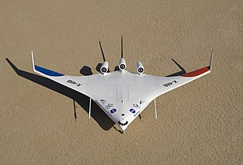

*Figure 2.5 Boeing X-48 B*

The X48B was remotely controlled aircraft, built to 8.5 % scale model of potentially flying aircraft. Flight tests demonstrated that BWB aircraft can be flown as safely as current transport having traditional fuselage, wings and tail configuration.

The X-48B has a 21-foot (6.4 m) wingspan, weighs 392 pounds (178 kg), and is built from composite materials. It is powered by three small turbojet engines and is expected to fly at up to 120 knots (220 km/h) and reach an altitude of 10,000 feet (3,000 m). The X-48B is an 8.5% scaled version of a conceptual 240 feet (73 m) span design. Though passenger versions of the X-48B have been proposed, the design has a higher probability of first being used for a military transport.

The X-48B first flew on July 20, 2007, reaching an altitude of 7,500 ft (2,286 m); the flight lasting 31 minutes. The remotely piloted aircraft was successfully stalled for the first time on September 4, 2008, with fixed leading-edge slats, a forward centre of gravity, and 23-degree angle of attack.

**2.4.5 Lockheed A-12:**

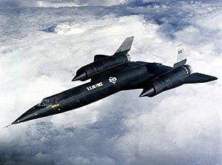

*Figure 2.6 Lockheed A-12*

The **Lockheed A-12** was a high-altitude, Mach 3+ reconnaissance aircraft built for the United States Central Intelligence Agency (CIA) by Lockheed's Skunk Works, based on the designs of Clarence "Kelly" Johnson. The aircraft was designated A-12, the 12th in a series of internal design efforts for "Archangel", the aircraft's internal code name. In 1959, it was selected over Convair's FISH and Kingfish designs as the winner of Project GUSTO, and was developed and operated under Project Oxcart.

Because the A-12 was well ahead of its time, many new technologies had to be invented specifically for the Oxcart project with some remaining in use in present day. One of the biggest problems that engineers faced at that time was working with titanium.

Before the A-12, titanium was used only in high-temperature exhaust fairings and other small parts directly related to supporting, cooling, or shaping high-temperature areas on aircraft like those subject to the greatest kinetic heating from the airstream, such as wing leading edges. The A-12, however, was constructed mainly of titanium. Titanium is quite rigid and difficult to machine, which made it difficult to form into curves given available techniques. This made it difficult to form the leading edges of the wing and similar surfaces. The solution was found by machining only small "fillets" of the material with the required shape and then gluing them onto the underlying framework which was more linear. A good example is on the wing; the underlying framework of spars and stringers formed a grid, leaving triangular notches along the leading edge that were filled with fillets.

**2.5 Twin Fuselage Aircrafts:**

**2.5.1 Applications of Twin Fuselage in Aircrafts:**

1. A twin-float arrangement offers stability without the need for wing tip stabilising floats.
2. The fuselage provides a strong airframe with minimal additional weight.

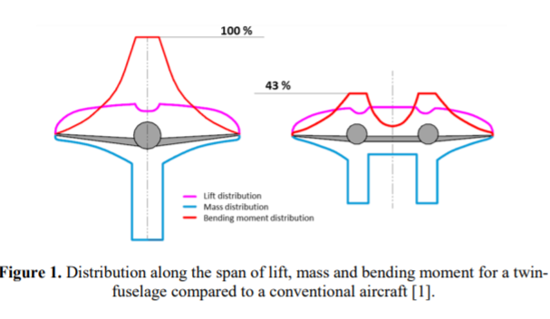

*Figure 2.7 Twin fuselage advantages*

**2.5.2 Disadvantages of Twin Fuselage in Aircrafts:**

1. low fuel efficiency of such aircraft
2. the increased drag runs
3. the increased aircraft mass

* But as the blended wing covers the fuselage into the wing, the drag decrease and lift increase therefore pertaining to make the extra weight negligible.

**2.6 Study of different types of Twin Fuselage aircrafts:**

**2.6.1 North American F-82 Twin Mustang:**

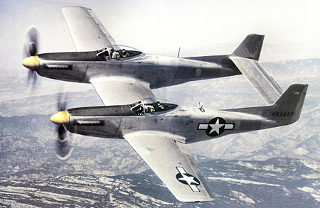

*Figure 2.8 North American F-82 Twin Mustang*

Initially intended as a very long-range (VLR) escort fighter, the F-82 was designed to escort Boeing B-29 Superfortress bombers on missions exceeding 2,000 mi (3,200 km). In October 1943, the North American Aircraft design team began work on a fighter design that could travel over 2,000 mi (3,200 km) without refuelling. It consisted of a twin-fuselage design.

In October 1943, the North American Aircraft design team began work on a fighter design that could travel over 2,000 mi (3,200 km) without refuelling. It consisted of a twin-fuselage design, parallel to the experimental German Messerschmitt Bf 109Z "Zwilling". Although based on the lightweight experimental XP-51F, which would later become the P-51H Mustang, it was actually a new design. North American Design Chief Edgar Schmued incorporated two P-51H Mustang fuselages lengthened by the addition of a 57 in (1,400 mm) fuselage plug located behind the cockpit where additional fuel tanks and equipment could be installed. These were mounted to a newly designed centre wing section containing the same six .5 in (13 mm) M3 Browning machine guns as a single-engine Mustang, but with more concentrated fire. The first XP-82 prototype was equipped with a removable centreline gun pod housing eight additional .50 calibre M3 Brownings, but this did not feature on production aircraft. An even more powerful centreline gun pod containing a 40 mm (1.6 in) cannon was considered, but was never built. The outer wings were reinforced to allow the addition of hard points for carrying additional fuel or 1,000 lb (450 kg) of ordnance. The two vertical tails were also from the XP-51F, but incorporated large dorsal fillets for added stability in case of an engine failure. The aircraft had a conventional landing gear with both wheels retracting into bays under each fuselage centre section.

The XP-82 was to be powered by two Packard-built Rolls-Royce V-1650 Merlin engines. Initially, the left engine was a V-1650-23 with an additional gear in the propeller reduction box to allow the left propeller to turn opposite to the right propeller, which was driven by the more conventional V-1650-25. In this arrangement both propellers would turn upward as they approached the centre wing, which in theory would have allowed better single-engine control. This proved not to be the case when the aircraft refused to become airborne during its first flight attempt. After a month of work North American engineers finally discovered that rotating the propellers to meet in the centre on their upward turn created sufficient drag to cancel out all lift from the centre wing section, one quarter of the aircraft's total wing surface area. The engines and propellers were then exchanged, with their rotation meeting on the downward turn, and the problem was fully solved. The first XP-82 prototype (*44-83886*) was completed on 25 May 1945 and made the type's first successful flight on 26 June 1945. This aircraft was accepted by the Army Air Forces on 30 August 1945, whose officials were so impressed by the aircraft, while still in development

**2.6.2 Belyayev DB-LK:**

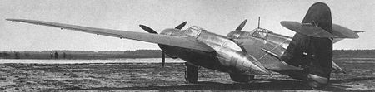

*Figure 2.9 Belyayev DB-LK*

Belyaev developed the twin boom idea into the twin-fuselage DB-LK, which had two short fuselages either side of a very long chord wing centre section, with the outer wing sections swept forward 5-degree 42 min, tapering at 7:1 out to raked back tips. A large fin and rudder on a short central boom, carried a small tailplane with very large elevators. The airframe was of light alloy stressed skin construction with five spar wings covered with sheet aluminium alloy. Each fuselage pod carried a single M-88 engine in a long chord cowling, driving a three-bladed VISh-23D propeller

**2.6.3 Blériot 125:**

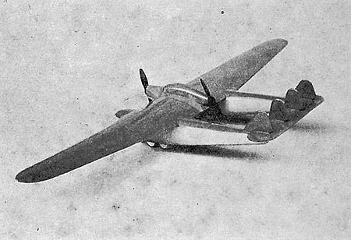

*Figure 2.10 Blériot 125*

The **Blériot 125** (or **Bl-125**) was a highly unusual French airliner of the early 1930s. Displayed at the 1930 *Salon de l'Aéronautique* in Paris, it featured accommodation for twelve passengers in separate twin fuselages. Between them, these pods shared a tailplane and a high wing. The centre section of wing joined the fuselage pods and also carried a nacelle that contained an engine at either end and the crew compartment in the middle. When flown the following year, it displayed very poor flight characteristics and although attempts to improve it continued on into 1933, certification could not be achieved, and the sole prototype was scrapped the following year.

**2.6.4 Savoia-Marchetti SM.92:**

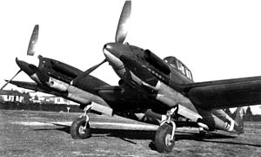

*Figure 2.11 Savoia-Marchetti SM.92*

The Savoia-Marchetti SM.92 was an Italian heavy fighter/bomber of World War II based on the Savoia-Marchetti SM.88. The crew of two sat in the left fuselage only. Two DB 605 engines were fitted.

During development the maximum speed was increased, but it still did not meet requirements. It had a complex and advanced structure which contributed to difficulties in producing a working prototype. The prototype *MM.531* flew for the first time in October 1943 and logged over 21 hours of flight time.

**2.6.5 Tupolev ANT-22:**

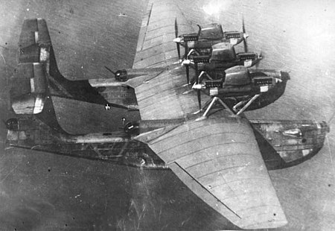

*Figure 2.12 Tupolev ANT-22*

The Tupolev ANT-22 or MK-1 with six 619kW M-34R engines was a long-range bomber reconnaissance flying-boat, its twin-hull design clearly inspired by the Italian Savoia-Marchetti S.55. Test flown for the first time on 8 August 1934, it established several weight-to-height world records in December 1936 but was abandoned soon afterwards. Armament comprised eight 7.7mm ShKAS machine-guns, one 20mm cannon and a bombload of up to 6000kg. The MK-1 spanned 51.00m and had a maximum speed of 223km/h. A huge aircraft consisting of two hulls and powered by six engines in three nacelles in a push-pull configuration.

**CHAPTER 3**

**PREPARATION OF COMPARATIVE DATA SHEET OF DIFFERENT AIRCRAFTS**

**3.1 Data Collection:**

Data is collected based on the above information and tabulated for clarity. Graphs are plotted for the 10 aircrafts.

**3.1.1 General Characteristics**

The following table gives the general characteristics of the selected aircrafts.

*Table 3.1 General Characteristics*

|  |  |  |  |  |  |  |  |
| --- | --- | --- | --- | --- | --- | --- | --- |
| **Aircraft\Data** | **Cruising speed,** *kmph* | **Crew** | **Length,** *m* | **Height,** *m* | **Wing area ,** *m2* | **Wing span ,** *m* | **Aspect ratio** |
| Northrop YB 49 | 587 | 6 | 16.18 | 4.62 | 370 | 52.34 | 7.2 |
| Northrop B2 Stealth Bomber | 900 | 2 | 21 | 5.18 | 478 | 52.4 | 9.1 |
| Lockheed SR 71 Blackbird | 1000 | 2 | 32.74 | 5.64 | 170 | 16.94 | 1.7 |
| Boeing X 48 -B | 219 | none | - | - | 9.34 | 6.4 | 4.1 |
| Lockheed A 12 | 1000 | 1 | 30.96 | 5.64 | 166.8 | 16.94 | 1.72 |
| North American  F-82 Mustang | 460 | 2 | 12.93 | 4.22 | 37.9 | 15.62 | 6.4 |
| Belyayev DB-LK | 488 | 4 | 9.78 | 3.65 | 56.87 | 21.6 | 8.2 |
| Bierot 125 | 220 | 3 | 13.83 | 4 | 100 | 29.4 | 8.64 |
| Savoia-Marchetti SM 92 | 539 | 2 | 13.7 | 4.15 | 38.52 | 18.55 | 8.93 |
| Tupolev ANT-22 | 180 | 8 | 24.1 | 8.96 | 304.5 | 51.0 | 8.54 |

**3.1.2 Weight Configuration**

The following table gives the weight configuration of the selected aircrafts.

*Table 3.2 Weight Configuration*

|  |  |  |  |  |
| --- | --- | --- | --- | --- |
| **Aircraft\Data** | **Cruising speed,** *kmph* | **Empty weight ,** *kg* | **Maximum Takeoff weight ,** *kg* | **Gross Weight,** *kg* |
| Northrop YB 49 | 587 | 40117 | 87969 | 60586 |
| Northrop B2 Stealth Bomber | 900 | 71700 | 170600 | 152200 |
| Lockheed SR71 Blackbird | 1000 | 30617 | 78018 | 68946 |
| Boeing X 48 B | 219 | 178 | 300 | 227 |
| Lockheed A12 | 1000 | 24000 | 53070 | 47000 |
| North American F-82 Twin Mustang | 460 | 7256 | 11608 | 9990 |
| Belyayev DB-LK | 488 | 6004 | 11000 | 10672 |
| Bleriot 125 | 220 | 4440 | 9000 | 7260 |
| Savaio-Marchetti SM 92 | 539 | 5900 | 10000 | 8750 |
| Tupelov ANT-22 | 180 | 21663 | 33,560 | 24494 |

**3.1.3 Performance**

The following table gives the performance of the selected aircrafts.

*Table 3.3 Performance*

|  |  |  |  |  |  |  |
| --- | --- | --- | --- | --- | --- | --- |
| **Aircraft\Data** | **Cruising speed,** *kmph* | **Maximum speed,** *Mach* | **Service Ceiling,** *m* | **Range,** *Km* | **Rate of climb,***mpm* | **Wing loading,** *kg/m²* |
| Northrop YB 49 | 587 | 0.64 | 13900 | 16058 | 1153.8 | 160 |
| Northrop B2 Stealth Bomber | 900 | 0.95 | 15200 | 11000 | 914.4 | 318.41 |
| Lockheed SR71 Blackbird | 1000 | 3.4 | 26000 | 5230 | 3600 | 410 |
| Boeing X 48 B | 219 | 0.177 | 3000 | - | - | 24.3 |
| Lockheed A12 | 1000 | 3.35 | 26000 | 4600 | 3600 | 318.165 |
| North American F-82 Twin Mustang | 460 | 0.6 | 38900 | 3600 | 1149.096 | 27.127 |
| Belyayev DB-LK | 488 | 0.395 | 8500 | 2900 | 369 | 187.65 |
| Bleriot 125 | 220 | 0.178 | - | 1000 | - | 72.6 |
| Savoia-Marchetti SM 92 | 539 | 0.497 | 12000 | 2000 | 857.14 | 227.15 |
| Tupolev ANT 22 | 180 | 0.188 | 3500 | 1350 | 96 | 110.21 |

**CHAPTER 4**

**PREPARATION OF COMPARATIVE GRAPHS**

**4.1 Graph Plotting**

The graphs are plotted for the tabulated data from the previous section. The inference from these graphs will give us the tentative design parameters

**4.1.1 Cruising Speed vs Crew**

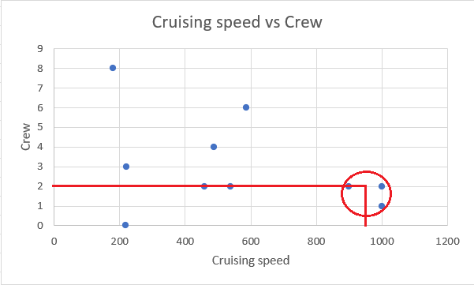

*Figure 4.1Graph: Cruising speed Vs Crew*

**4.1.2 Cruising Speed vs Length**

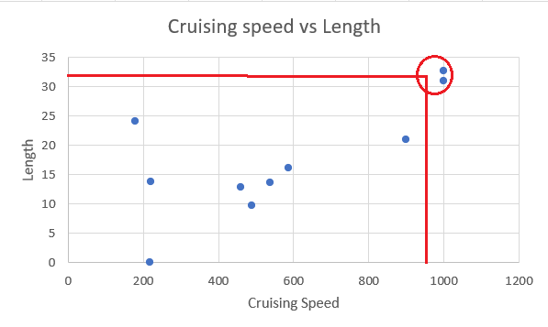

*Figure 4.2 Graph: Cruising Speed vs Length*

**4.1.3 Cruising Speed vs Height**

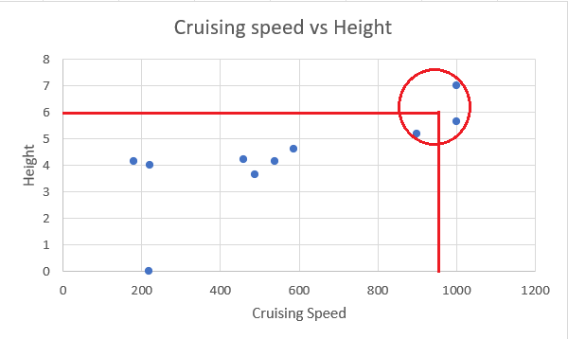

*Figure 4.3 Graph: Cruising Speed vs Height*

**4.1.4 Cruising Speed vs Wing Area**

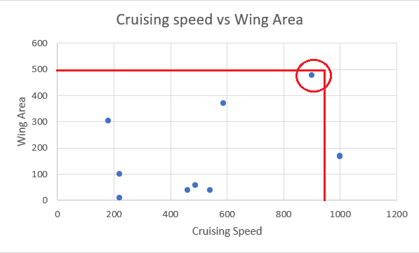

*Figure 4.4 Graph: Cruising Speed vs Wing Area*

**4.1.5 Cruising Speed vs Wingspan**

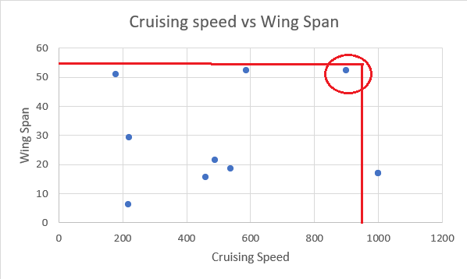

*Figure 4.5 Graph: Cruising Speed vs Wingspan*

**4.1.6 Cruising Speed vs Aspect Ratio**

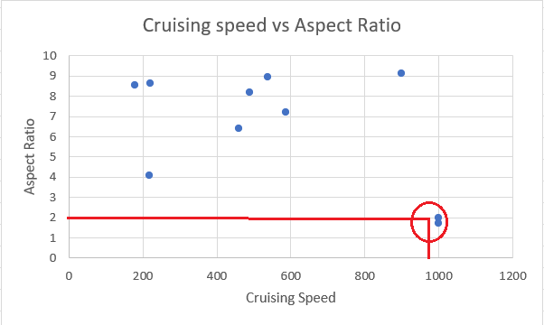

*Figure 4.6 Graph: Cruising Speed vs Aspect Ratio*

**4.1.7 Cruising Speed vs Empty Weight**

**­­**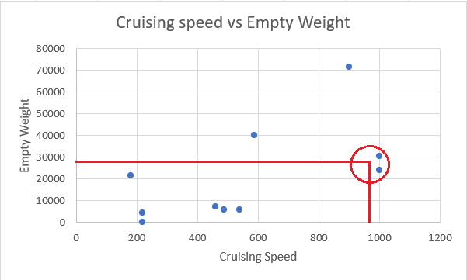

*Figure 4.7 Graph: Cruising Speed vs Empty Weight*

**4.1.8 Cruising Speed vs Maximum Take-off Weight**

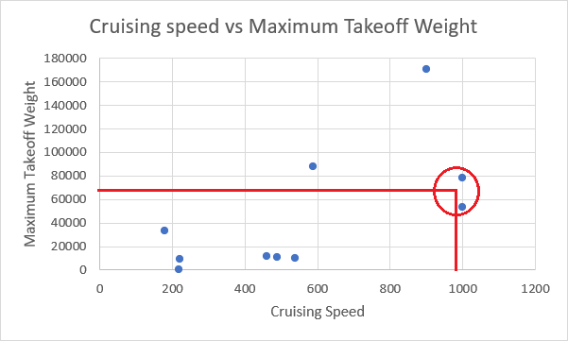

*Figure 4.8 Graph: Cruising Speed vs Takeoff Weight*

**4.1.9 Cruising Speed vs Gross Weight**

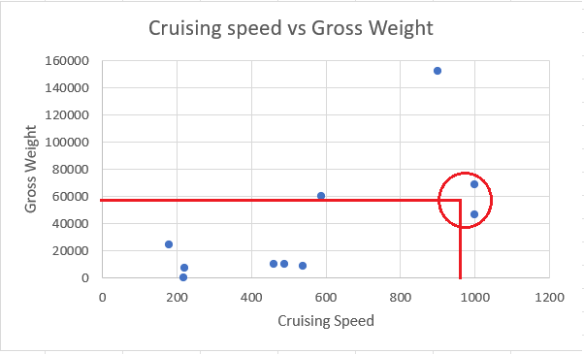

*Figure 4.9 Graph: Cruising Speed vs Gross Weight*

**4.1.10 Cruising Speed vs Maximum Speed**

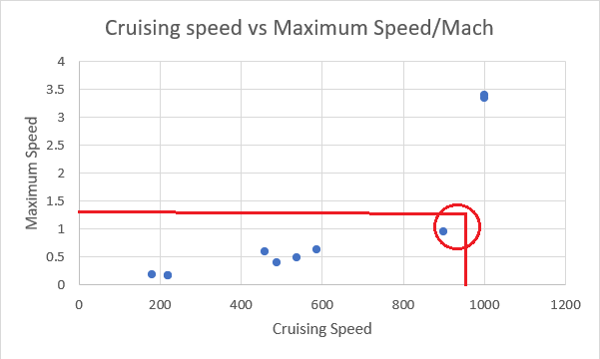

*Figure 4.10 Graph: Cruising Speed vs maximum speed*

**4.1.11 Cruising Speed vs Service Ceiling**

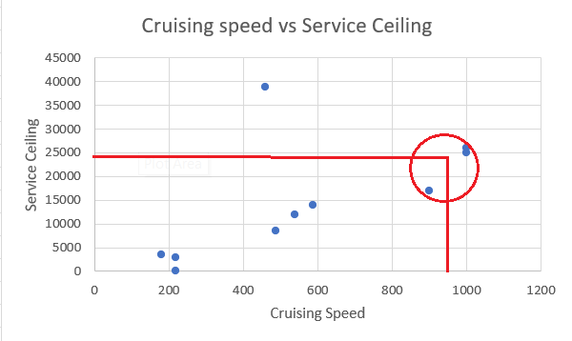

*Figure 4.11 Graph: Cruising Speed vs Service Ceiling*

**4.1.12 Cruising Speed vs Range**

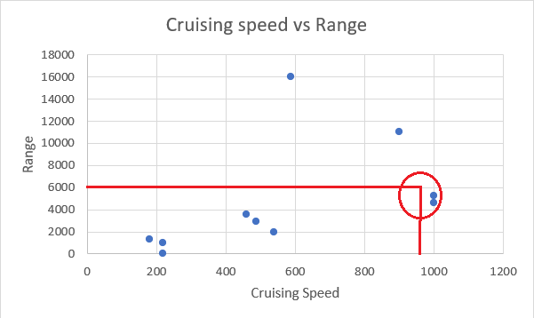

*Figure 4.12 Graph: Cruising Speed vs Range*

**4.1.13 Cruising Speed vs Wing Loading**

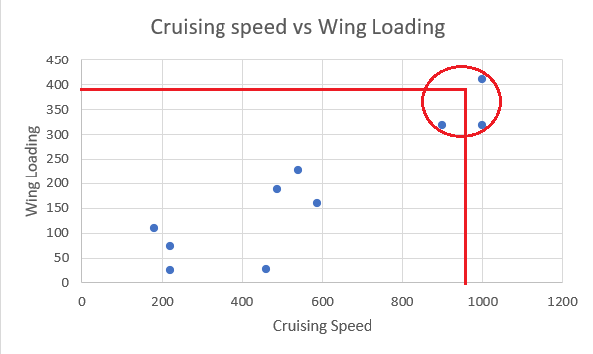

*Figure 4.12 Graph: Cruising Speed vs Wing Loading*

**CHAPTER 5**

**SELECTION OF TENTATIVE DESIGN PARAMETERS**

**5.1 Tentative Design Parameters**

Based on the comparative study as well as the graphs plotted from the tabulated data of the selected 10 aircrafts, we have selected the tentative design parameters for the aircraft. These parameters will be used to proceed with the design steps and weight estimation processes.

* + 1. **General Characteristics**

The tentative parameters for the general characteristics for the design are listed as follows,

1. Crew : 2
2. Length : 33 *m*
3. Height : 6 *m*
4. Wing area : 430 *m2*
5. Wingspan : 55 *m*
6. Aspect ratio : 7.034
7. Cruising speed : 950 *kmph*
   * 1. **Weight Configuration**

The tentative parameters for the weight configuration for the design are listed as follows,

1. Empty weight : 29000 *kg*
2. Maximum Take-Off weight : 65000 *kg*
3. Gross Weight : 55000 *kg*
4. Thrust to Weight ratio : 0.40
   * 1. **Performance**

The tentative parameters for the performance for the design are listed as follows,

1. Maximum speed : 1.25 *Mach*
2. Service Ceiling : 15500 *m*
3. Range : 6000 *km*
4. Wing Loading : 400 *kg/m2*

**CHAPTER 6**

**FLIGHT PROFILE AND WEIGHT ESTIMATION**

**6.1 Flight Profile**

Flight profile can be defined as a graphic representation of the flight path of an aircraft in the vertical plane, giving altitude, speed, range, manoeuvre, and the number of stops etc. of the aircraft as observed from the side. A flight plan plays a very important role as it helps us to be prepared in advance. The following is the flight profile of the aircraft.

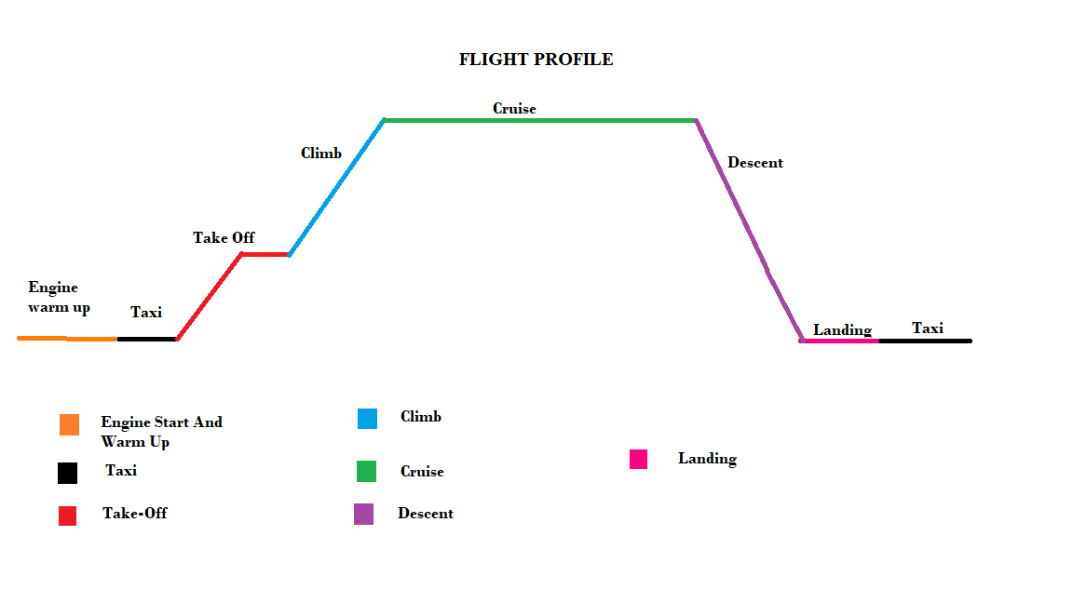

*Figure 6.1 Flight Profile*

1. **Engine Start and Warm Up:**

The aircraft’s engines are started and warmed up. This helps the aircraft in taxiing an take-off.

1. **Taxiing:**

The aircraft is taxied to align with the runway before taking off.

1. **Take-off:**

The aircraft takes off from the runway.

1. **Climb:**

The aircraft climbs to reach its maximum altitude where it will continue the next phase.

1. **Cruise:**

The aircraft travels in the maximum altitude in the cruising speed efficiently.

1. **Descent:**

After the aircraft has travelled 60-70% of its course, it starts to descend.

1. **Landing and Taxiing:**

The aircraft completes the journey and lands. After landing, the aircraft is taxied to the warehouse.

**6.2 Weight Estimation:**

The following are the steps involved in weight estimation of the designed aircraft.

**6.2.1 Payload Weight:**

The following is the calculation for the maximum payload weight of the aircraft. Considering the maximum weight of 1 passenger as 80 kgs and maximum allowable baggage weight for each passenger as 13.6 kgs,

For 10 passengers along with baggage, Wpl = (Wbombs)*(no. of bombs)

* Wpl = (370) *42
* Wpl = 15540 kgs

**6.2.2 Crew Weight:**

The following is the calculation for the maximum weight of the crew in the aircraft. Considering the maximum weight of 1 crew member as 175 lbs and maximum allowable baggage weight for each crew member as 30 lbs,

For 2 crew members along with their baggage, Wcr = (Wcrew + WBaggage) * (No. of crew members)

* Wcr = (90) *2
* Wcr = 180 kgs

**6.2.3 WEIGHT RATIO CALCULATIONS**

The weight ratio is used to obtain the weight of the aircraft at various stages. It is then used to calculate Mff which is used in calculation of Wused. The below calculations are made considering WTo Guess as Take-off weight i.e., 65000 kgs or 143300.471 lbs.

The following tables are used to obtain the weight ratios of respective phases along with cruise and loiter,

*Table 6.1 Fuel –Fraction for Several Mission Phases*

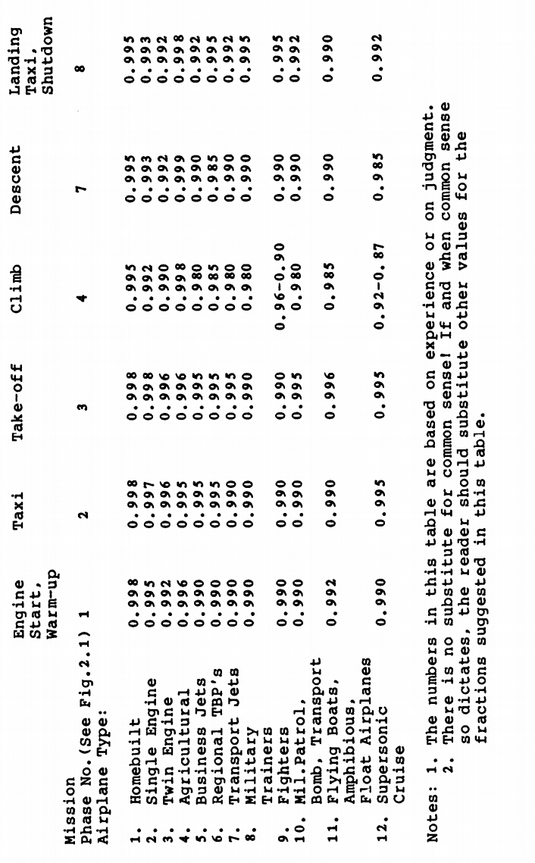

*Table 6.2 Mission Cruise and loiter parameter for Several Phases*

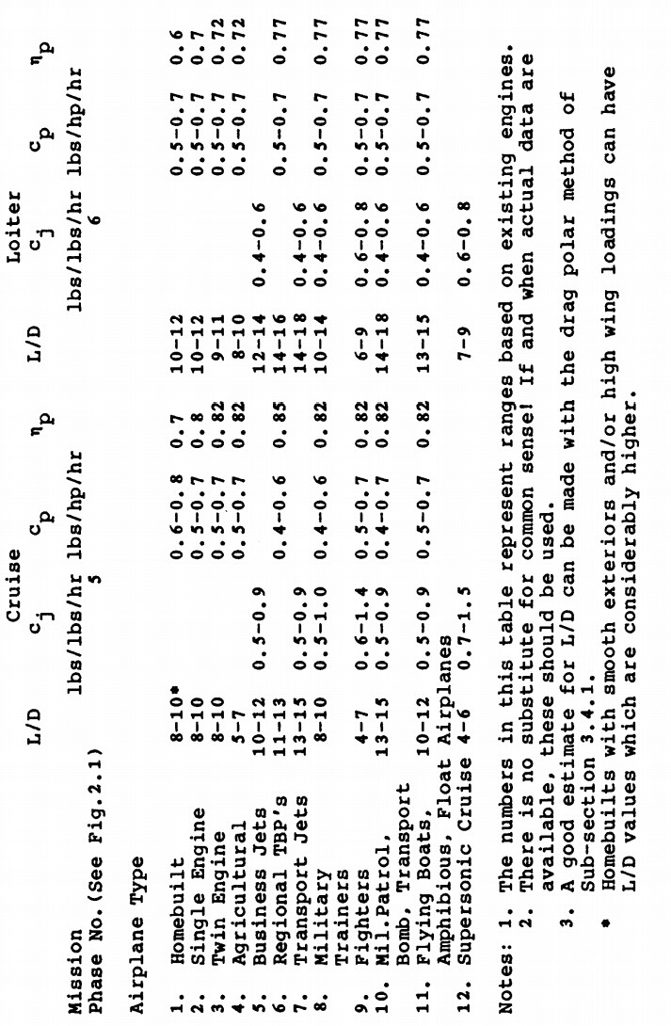

1. **ENGINE START & WARM UP:**

The following calculation gives the weight of the aircraft in the engine start and warm up phase,

* W1 = WTo Guess  * 0.990
* W1 = 65000 * 0.990
* W1 = 64350 kgs.

1. **TAXIING:**

The following calculation gives the weight of the aircraft in the taxiing phase,

* W2 = W1 * 0.990
* W2 = 64350 * 0.990
* W2 = 63706.5 kgs.

1. **TAKE-OFF**:

The following calculation gives the weight of the aircraft in the take-off phase,

* W3 = W2 * 0.995
* W3 = 63706.5 * 0.995
* W3 = 63387.968 kgs.

1. **CLIMB**:

The following calculation gives the weight of the aircraft in the take-off phase,

* W4 = W2 * 0.980
* W4 = 63387.968 * 0.980
* W4 = 62120.209 kgs.

**V. CRUISE**:

The Range of the aircraft is given by the following equation and W5 is calculated from the same,

The following values are taken from the table,

Rcr = 3500 kms

V = 950 kmph

Cj = 0.7

L/D = 14

* W5  = 0.832 * 62120.209
* W5  = 51683.014 kgs.

1. **DESCENT**:

The following calculation gives the weight of the aircraft in the descent phase,

* W6 = W2 * 0.990
* W6 = 51683.014 * 0.990
* W6 = 51166.184 kgs.

1. **LANDING & TAXIING**:

The following calculation gives the weight of the aircraft in the landing and taxiing phase,

* W7 = W6 * 0.998
* W7 = 51166.184 * 0.998
* W7 = 51063.852 kgs

**Calculation of Mff :**

The Mff is given by the following formula,

* Mff  = 0.7856

**6.2.4 WEIGHT OF FUEL**

The weight of the fuel, Wf is calculated using the following formula, Wf = (Wused + Wres)

Where, Wused = (1 - Mff) * WTo Guess

Wres = 10-25% of Wused

* Wused = (1 – 0.7856) * 65000
* Wused = 0.2144 * 65000
* Wused = 13936 kgs.
* Wres = 10% of Wused
* Wres = 0.1 * 13936
* Wres = 1393.6 kgs.
* Wf = (Wused + Wres)
* Wf = 13936 + 1393.6
* Wf = 15329.6 kgs.

**6.2.5 WOE Tentative**

The WOE Tentative is calculated using the following formula, WOE Tentative = WTo Guess - Wf – Wpl

Where, WTo Guess = 65000 kgs.

Wf = 15329.6 kgs.

Wpl =15540 kgs

WOE Tentative = 65000– 15329.6 –15540

* WOE Tentative = 34230.4 kgs.

**6.2.6 WE Tentative**

The WE Tentative is calculated using the following formula, WE Tentative = WOE Tentative – WTFO – Wcrew

Where, WOE Tentative = 34230.4 kgs.

WTFO = 171.152 kgs

Wcrew = 180 kgs

* WE Tentative = 34230.4 – 171.152 – 180
* WE Tentative = 33879.248 kgs

**6.2.7 WE Actual**

The WE Actual is calculated using the following formula,

The values of A and B are obtained from the following table,

*Table 6.3 WE Values*

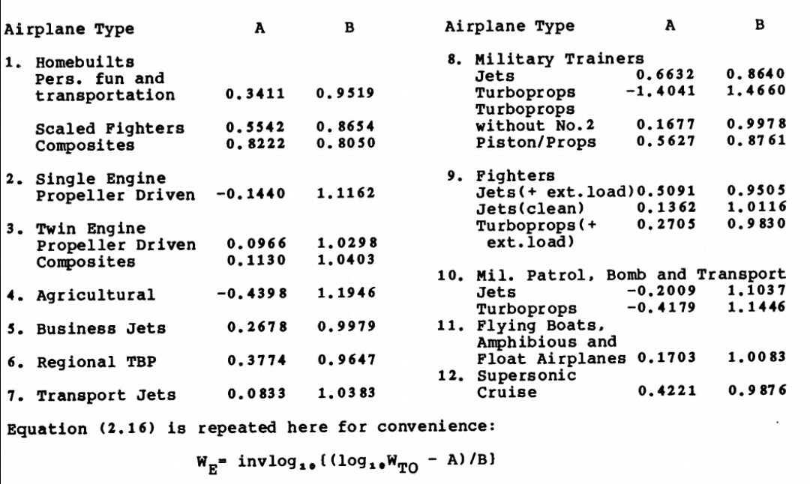

Where, A = -0.2009

B= 1.1037

**6.2.8 Error percentage**

The Error is given by the following formula,

Where, WE Actual = kgs.

WE Tentative = 33879.248 kgs.

* Error % = 2.74 %

**6.2.9 Conclusion**

Thus, the weight estimation for the aircraft has been calculated and all the values can be observed from the above steps. The weight estimation has been done with an error percentage of 1.5% which ensures the accuracy of the calculations done. The following data are obtained from the calculations,

*Table 6.4 Weight Parameters*

|  |  |
| --- | --- |
| **Name** | **Parameters** |
| Take Off Weight | 65000 kgs |
| Fuel Weight | 15329.6 kgs. |
| Actual weight | 33879.24 kgs. |

**CHAPTER 7**

**AEROFOIL AND WING SELECTION**

**7.1 WING SELECTION**

We will select the wing and its configuration in this chapter. We have also given the appropriate reason for the selection of our components respectively.

**7.1.1 NUMBER OF WINGS**

There are different configurations of wings based on number of wings present in the fuselage of the aircraft. They are predominantly classified as,

* Monoplane
* Biplane
* Triplane

**7.1.1.1 MONOPLANE**

A monoplane is a fixed-wing aircraft with a single main wing plane. A monoplane has inherently the highest efficiency and lowest drag of any wing configuration and is the simplest to build. However, during the early years of flight, these advantages were offset by its greater weight and lower manoeuvrability, making it relatively rare until the 1930 since then, the monoplane has been the most common form for a fixed-wing.

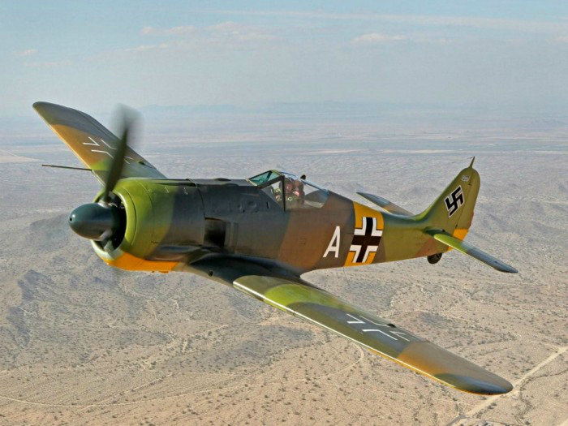

*Figure 7.1 MONOPLANE*

**7.1.1.2 BIPLANE**

A biplane is a fixed-wing aircraft with two main wings stacked one above the other. The first powered, controlled aeroplane to fly, the Wright Flyer, used a biplane wing arrangement, as did many aircraft in the early years of aviation. While a biplane wing structure has a structural advantage over a monoplane, it produces more drag than a similar unbraced or cantilever monoplane wing.

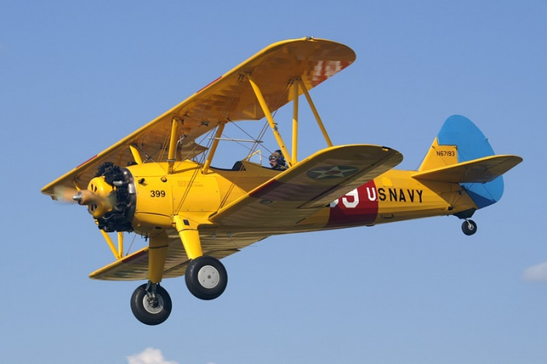

*Figure 7.2 BIPLANE*

**7.1.1.3 TRIPLANE**

A tri plane arrangement has a narrower wing chord than a biplane of similar span and area. This gives each wing-plane a slender appearance with higher aspect ratio, making it more efficient and giving increased lift. This potentially offers a faster rate of climb and tighter turning radius, both of which are important in a fighter. A tri plane is a fixed-wing aircraft equipped with three vertical stacked wing planes.

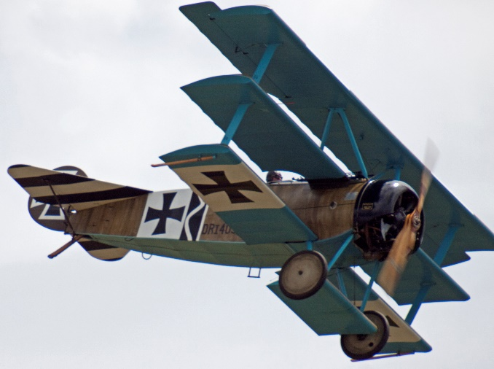

*Figure 7.3 TRIPLANE*

**SELECTION:**

The **Monoplane** wing configuration has been selected for the following reasons,

* A high or low wing cabin monoplane is readily adapted to carry additional petrol tanks, probably more readily adapted than any other class of aircraft.
* It has minimum weight compared to other configurations.
* Mono plane has lower span and chord, reducing the structural forces and allowing it to be lighter.

**7.1.2 WING SUPPORT**

The type of support of a wing can determine the strength of the aircraft during flight. Wings are also classified based on their type of support, they are,

* Cantilever
* Semi-Cantilever

**7.1.2.1 CANTILEVER**

A cantilever is a rigid structural element, such as a beam or a plate, anchored at one end to a usually vertical support from which it protrudes; this connection could also be perpendicular to a flat, vertical surface such as a wall. Cantilevers can also be constructed with trusses or slabs. These types of wings are mostly preferred in modern aircrafts.

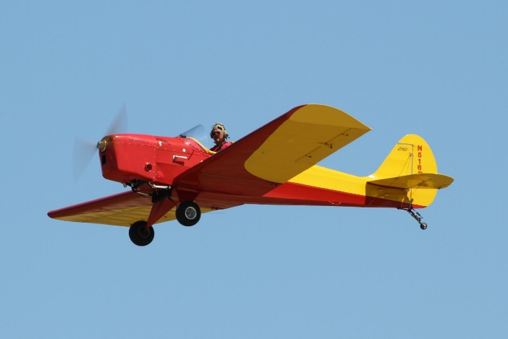

*Figure 7.4 CANTILEVER SUPPORT*

**7.1.2.2 SEMI-CANTILEVER**

The semi-cantilever usually has one, or perhaps two, supporting wires or struts attached to each wing and the fuselage. Many high-wing airplanes have external braces, or wing struts, which transmit the flight and landing loads through the struts to the main fuselage structure. Since the wing struts are usually attached approximately halfway out on the wing, this type of wing structure is called semi-cantilever.

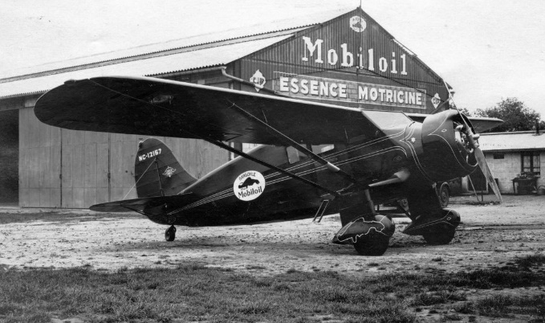

*Figure 7.5 SEMI-CANTILEVER SUPPORT*

**SELECTION:**

The **Cantilever** type wing support is selected for the following reasons,

* Cantilever arms are very rigid, because of their depth.
* The span can be greater than that of a simple beam, because a beam can be added to the cantilever arm.

**7.1.3 WING LOCATION**

The location of the wing also plays a major role in an aircraft. Wings are classified based on their location in the fuselage as follows,

* High wing
* Mid wing
* Low wing
* Shoulder
* Parasol
* Blended Wing

**7.1.3.1 HIGH WING**

A high wing is a configuration with the wings set on the top of the airplane’s body, called the fuselage. By design they provide both shade in the sun and an “umbrella” in the rain for passengers during boarding or debarking. On the ground they offer clearance over many fences.

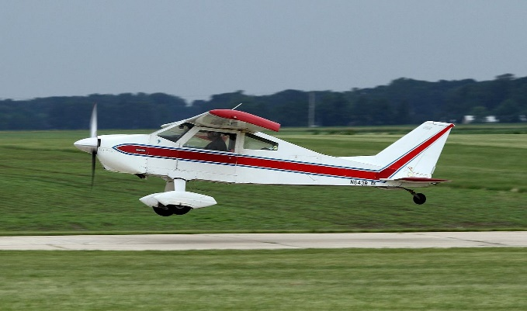

*Figure 7.6 HIGH WING*

**7.1.3.2 MID WING**

A mid-wing configuration places the wings exactly at the midline of the airplane, at half of the height of the fuselage. The mid-wing also has neutral roll stability, which is good from the perspective of combat and aerobatic aircraft as it allows for the performance of rapid roll manoeuvres with minimum yaw coupling.

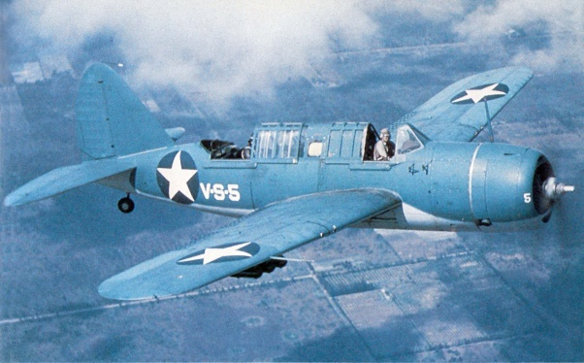

*Figure 7.7 MID WING*

**7.1.3.3 LOW WING**

Fuelling a low wing airplane usually does not involve a step ladder, and neither does checking the security of the fuel caps. The low wing being closer to the ground may allow for a shortened take-off roll and faster acceleration because of ground effect.

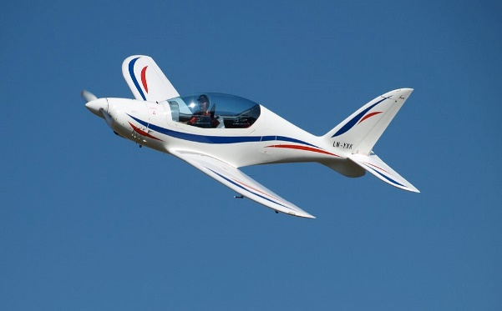

*Figure 7.8 LOW WING*

**7.1.3.4 SHOULDER WING**

A monoplane with a wing mounted near the top of the fuselage but not on the top; the wing is between the middle and the high position.

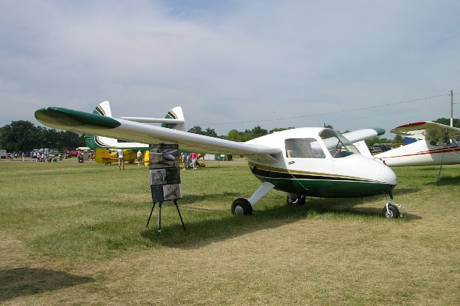

*Figure 7.9 SHOULDER WING*

**7.1.3.5 PARASOL WING**

A parasol wing aircraft is essentially a biplane without the lower pair of wings. The parasol wing is not directly attached to the fuselage, but is held above it, supported either by cabane struts or by a single pylon.

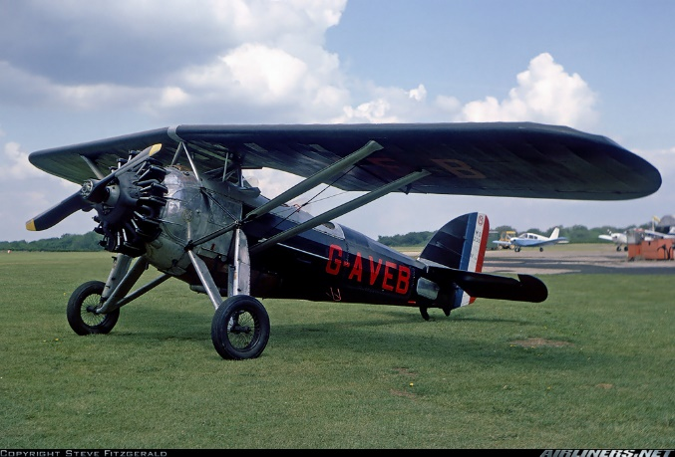

*Figure 7.10 PARASOL WING*

**7.1.3.6. BLENDED WING**

A **blended wing body** (**BWB**), also known as **blended body** or **hybrid wing body** (**HWB**), is a fixed-wing aircraft having no clear dividing line between the wings and the main body of the craft. The aircraft has distinct wing and body structures, which are smoothly blended together with no clear dividing line.

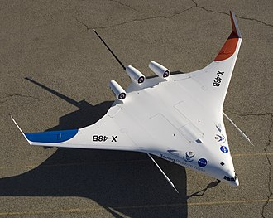

*Figure 7.11 BLENDED WING*

**SELECTION:**

The **blended wing** configurationis chosenfor the wing location. The reason for the selection is as follows,

* The main advantage of the BWB is to reduce wetted area and the accompanying form drag associated with a conventional wing-body junction.
* It may also be given a wide air foil-shaped body, allowing the entire craft to generate lift and thus reducing the size and drag of the wings.

**7.1.4 WING PLANFORM**

The wing planform allows the aircraft to have more control for stability and manoeuvrability. Wings are classified based on their planform as follows,

* Rectangle
* Elliptical
* Tapered
* Swept
* Swept forward
* Swept backward
* Delta
* Ogival
* Cranked
* Compound
* Cropped
* Tailed
* Tailless

**7.1.4.1 RECTANGLE WING**

Arguably the simplest wing planform from a manufacturing point of view, the rectangular wing is a straight, untapered wing.

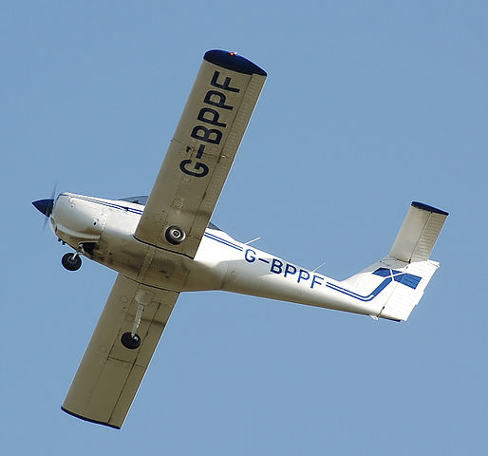

*Figure 7.12 RECTANGLE WING*

**7.1.4.2 ELLIPTICAL WING**

Aerodynamically, the elliptical plan form is the most efficient as elliptical span wise lift distribution has the lowest possible induced drag (as given by thin aerofoil theory). However, the most important disadvantage of the elliptical wing is that its manufacturability is poor.

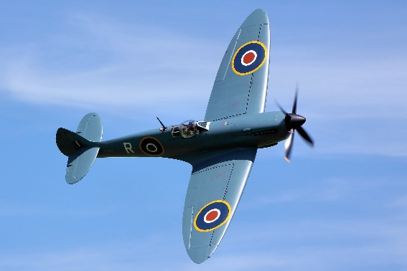

*Figure 7.13 ELLIPTICAL WING*

**7.1.4.3 TAPERED WING**

This is a modification of the rectangular wing where the chord is varied across the span to approximate the elliptical lift distribution. While not as efficient as the elliptical lift distribution, it offers a compromise between manufacturability and efficiency.

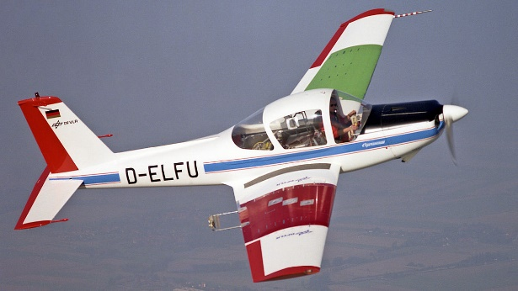

*Figure 7.14 TAPERED WING*

**7.1.4.4 SWEPT WING**

A swept wing is a wing that angles either backward or occasionally forward from its root rather than in a straight sideways direction. Wing sweep has the effect of delaying the shock waves and accompanying aerodynamic drag rise caused by fluid compressibility near the speed of sound, improving performance. The swept wings are classified as,

* Swept forward
* Swept backward

**Swept forward:**

Forward-swept wings make an aircraft harder to fly, but the advantages are mainly down to manoeuvrability. Wing sweep has the effect of delaying the shock waves and accompanying aerodynamic drag rise caused by fluid compressibility near the speed of sound, improving performance.

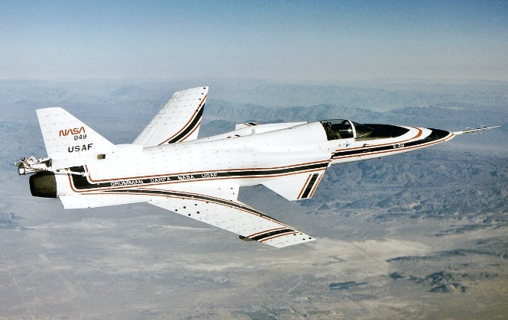

*Figure 7.15 SWEPT FORWARD WING*

**Swept backward:**

The leading edges of these wings are swept back. This is done order to reduce drag in transonic speeds, which is determined by the velocity normal to the wind. A swept wing is a wing that angles either backward.

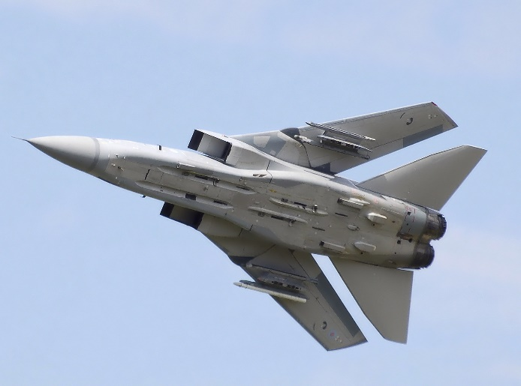

*Figure 7.16 SWEPT BACKWARD WING*

**7.1.4.5 DELTA WING**

The delta wing is a wing shaped in the form of a triangle. It is named for its similarity in shape to the Greek uppercase letter delta. Although long studied, it did not find significant applications until the jet age, when it proved suitable for high-speed subsonic and supersonic flight. The delta wings are classified as,

1. Tailless
2. Tailed
3. Cropped
4. Compound
5. Cranked
6. Ogival

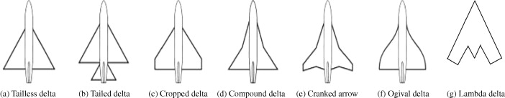

*Figure 7.17 TYPES OF DELTA WING*

**Tailless delta:**

Tailless aircraft has no tail assembly and no other horizontal surface besides its main wing. The aerodynamic control and stabilization functions in both pitch and roll are incorporated into the main wing.

**Tailed delta:**

A conventional tail stabilizer allows the main wing to be optimized for lift and therefore to be smaller and more highly loaded.

**Cropped delta:**

Wing tips are cut off. This helps avoid tip drag at high angles of attack. The Fairey Delta 1 also had a tail. At the extreme, merges into the "tapered swept" configuration.

**Compound delta:**

Inner section has a (usually) steeper leading-edge sweep as on the Saab Draken. This improves the lift at high angles of attack and delays or prevents stalling. By contrast, the Saab Viggen has an inner section of reduced sweep to avoid interference from its canard fore plane.

**Cranked delta:**

The goal of the cranked arrow was to have a high sweep inboard panel for low drag at supersonic speeds, and a low sweep outboard panel to provide better handling and manoeuvrability at subsonic speeds.

**Ogival delta:**

The Ogive is a type of supersonic wing used in high-speed aircraft. This is a complex mathematical shape derived for minimizing drag, especially at supersonic speeds. They offer excellent supersonic performance, with minimal drag.

**SELECTION:**

The **Cranked Arrow planform** will be implemented on the aircraft. The wing will also have a taper. The reason for the selection is as follows,

* High root thickness, so the wing can be made stiffer and stronger where the loads are highest.
* Better pitch stability in the post-stall region, so no AoA limit needs to be observed

**7.1.5 WING ANGLE**

The angle of the wing plays a major role in generating lift for the aircraft. The angles in a wing are classified as follows,

* Anhedral
* Straight
* Dihedral

**7.1.5.1 ANHEDRAL**

Anhedral angle, the downward angle from horizontal of the wings or tail plane of a fixed-wing aircraft. Anhedral angles are also seen on aircraft with a high mounted wing.

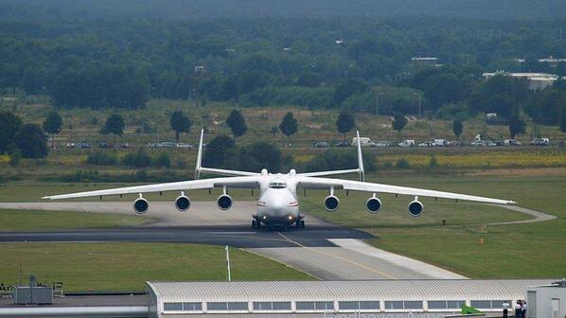

*Figure 7.18 ANHEDRAL WING*

**7.1.5.2 STRAIGHT**

The straight wing does not have any angle between the base of root chord and tip chord. These wings are naturally stable and generate enough lift in straight conditions.

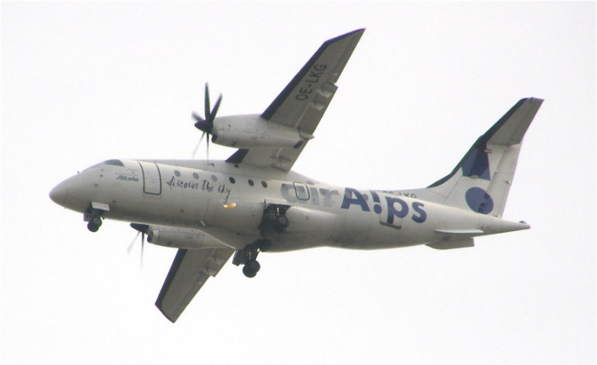

*Figure 7.19 STRAIGHT WING*

**7.1.5.3 DIHEDRAL**

Dihedral angle is the upward angle from horizontal of the wings or tail plane of a fixed-wing aircraft. It has a strong influence on dihedral effect.

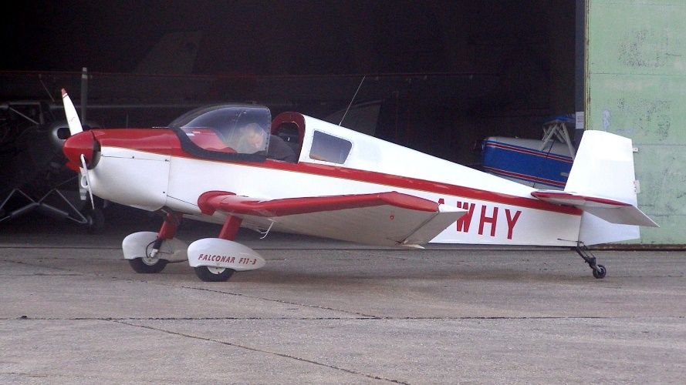

*Figure 7.20 DIHEDRAL WING*

**SELECTION:**

The **Straight wings** with a small dihedral angle will be implemented on the aircraft. The reason for the selection is as follows,

* The aircraft seems to generate enough lift with the existing straight wing configuration.
* Dihedral effect is a critical factor in the stability of an aircraft about the roll axis so it is also present little.

**7.2 REYNOLDS NUMBER**

The Reynolds number for our working conditions of the aircraft can be found by using the following formula,

Where, ρ = 0.1786 kg/m3

μ = 0.000014322 Ns/m

l = 20 m

V = 263.89 m/s

Thus, the Reynolds number for our conditions is found to be **65815883**.

**7.3 AIRFOIL SELECTION**

**7.3.1. Centre Air foil:**

The below table gives the table of selected centre air foils and their respective information,

*Table 7.1 Air foil Data*

|  |  |  |  |  |  |  |  |  |  |  |
| --- | --- | --- | --- | --- | --- | --- | --- | --- | --- | --- |
| **Name of Air foil** | **Thickness %** | **Cambered %** | **Alpha max** | **Cl max** | **(L/D)max** | **(Cl/Cd)max** | **Cdmin** | **Min Coeff of moment** | **Stall angle** | **Stall quality** |
| **Liebeck LA2573 A** | 13.7 | 3.2 | 10.5 | 1.3 | 18.549 | 125.8 | 0.0103 | 0.02 | 12 | good |
| **NACA 23112** | 12 | 1.2 | 4.5 | 1.55 | 42.28 | 98.6 | 0.0157 | 0.03 | 13 | bad |
| **Eppler 635** | 11.616 | 2.889 | 4 | 0.964 | 22.283 | 113.4 | 0.0254 | 0.04 | 14 | good |
| **MH62** | 9.3 | 1.5 | 6.5 | **1.2** | 67.879 | 98.3 | 0.0152 | -0.004 | 8 | medium |
| **MH60** | 10.28 | 1.8 | 6 | 0.906 | 65.726 | 94.6 | 0.0190 | 0.0175 | 9 | medium |

**Selection:** The **Liebeck LA2573 A** air foil has been selected for the aircraft. The diagram shows the selected air foil.

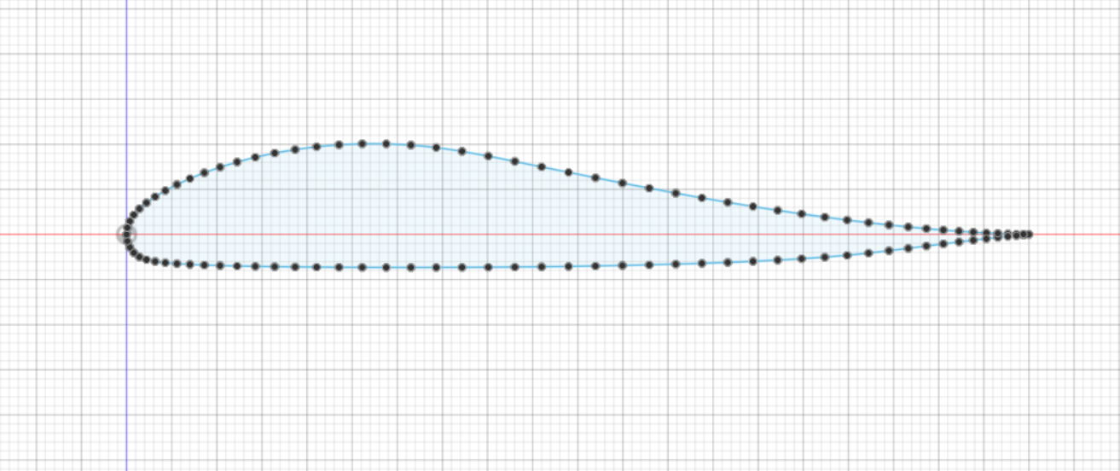

*Figure 7.21 Liebeck LA2573 A Aerofoil*

The above diagram is drawn in **Fusion 360** Software. The Co-ordinates of the air foil is obtained in data form and it is uploaded in the software to generate a precise view of the selected air foil.

The following is the selected air foil parameters.

*Table 7.2* **Liebeck LA2573 A** *Data*

|  |  |
| --- | --- |
| **Liebeck LA2573 A** | |
| Thickness% | 13.7 |
| Camber% | 3.2 |
| α max | 10.5 |
| Cl max | 1.3 |
| Stall Angle | 12 |
| (L/D) max | 130 |
| (Cl/Cd) max | 125.8 |
| (Cd) min | 0.0103 |
| Cm | 0.02 |
| Stall quality | Good |

**Performance Curves:**

The performance curves for the selected air foil are given as follows,

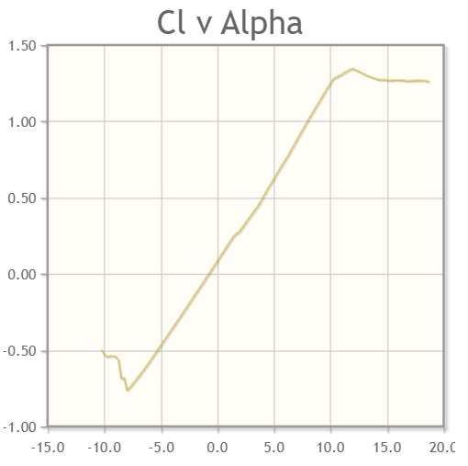

*Figure 7.22 Graph α Vs CL*

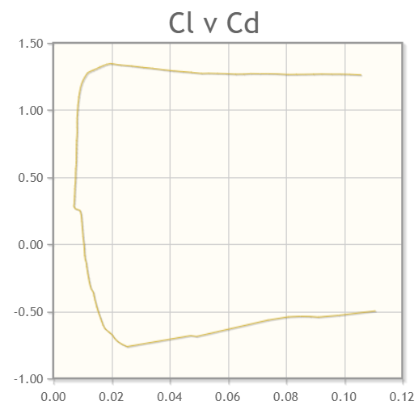

*Figure 7.23 Graph CL Vs CD*

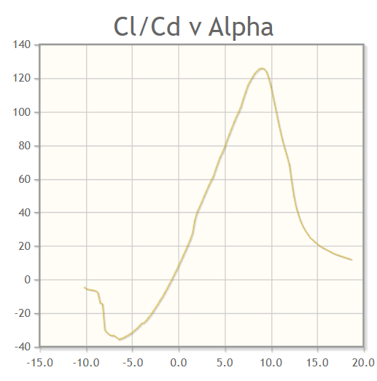

*Figure 7.24 Graph α Vs CL \CD*

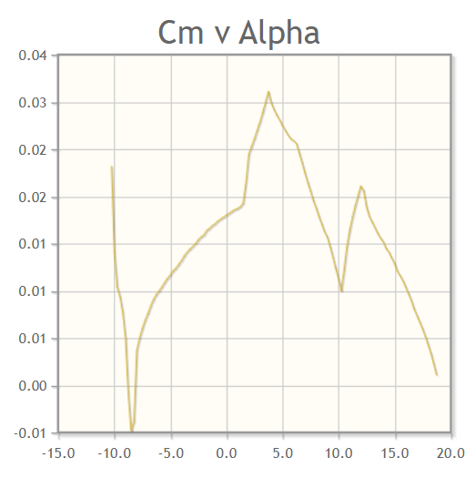

*Figure 7.25 Graph α Vs Cm*

**7.3.2. Tip Air foil:**

The below table gives the table of selected centre air foils and their respective information,

*Table 7.3 Air foil Data*

|  |  |  |  |  |  |  |  |  |  |
| --- | --- | --- | --- | --- | --- | --- | --- | --- | --- |
| **Name of Air foil** | **Thickness %** | **Cambered %** | **Alpha max** | **Cl max** | **(L/D)max** | **(Cl/Cd)max** | **Cdmin** | **Stall angle** | **Stall quality** |
| **FX60-126** | 12.6 | 4 | 8.75 | 1.491 | 145.5 | 113.3 | 0.01316 | 10 | good |
| **GOE 440** | 15.3 | 9.7 | 10.25 | 1.864 | 117.308 | 109.5 | 0.017023 | 0.5 | good |
| **Eppler 395** | 12.3 | 5.3 | 10.75 | 1.589 | 106.8 | 141.1 | 0.01126 | 8 | good |
| **FX 61-140** | 14.6 | 2.5 | 9.75 | 1.422 | 105.93 | 119 | 0.0119 | 6.5 | good |
| **MH 115** | 11.1 | 5.6 | 11.5 | 1.725 | 107.008 | 158.7 | 0.01087 | 7.0 | medium |

**SELECTION:**

The **Eppler 395** air foil has been selected for the aircraft. The diagram shows the selected air foil.

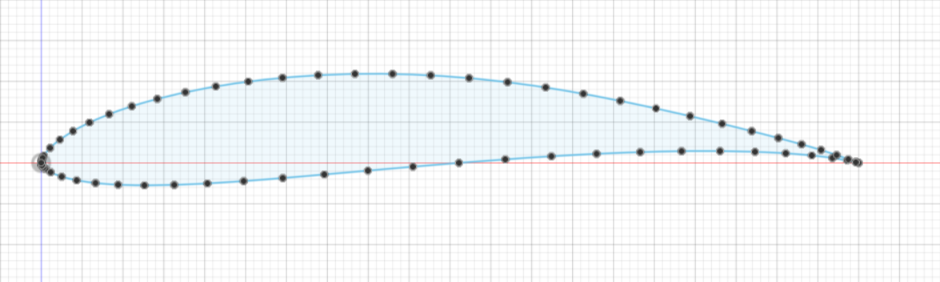

*Figure 7.26 Eppler 395 Air foil*

The above diagram is drawn in **Fusion 360** Software. The Coordinates of the air foil is obtained in data form and it is uploaded in the software to generate a precise view of the selected air foil.

*Table 7.4* **Eppler 395** *Data*

|  |  |
| --- | --- |
| **Eppler 395** | |
| Thickness% | 12.3 |
| Camber% | 5.3 |
| α max | 10.75 |
| Cl max | 1.589 |
| Stall Angle | 8 |
| (L/D) max | 106.8 |
| (Cl/Cd) max | 141.1 |
| (Cd) min | 0.01126 |
| Cm | 0 |
| Stall quality | Good |

**Performance Curves:**

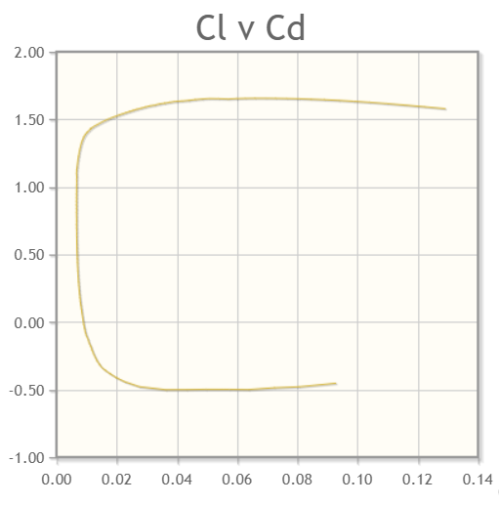

*Figure 7.27 Graph CL Vs CD*

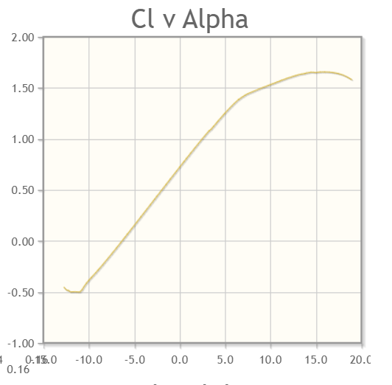

*Figure 7.28 Graph α Vs CL*

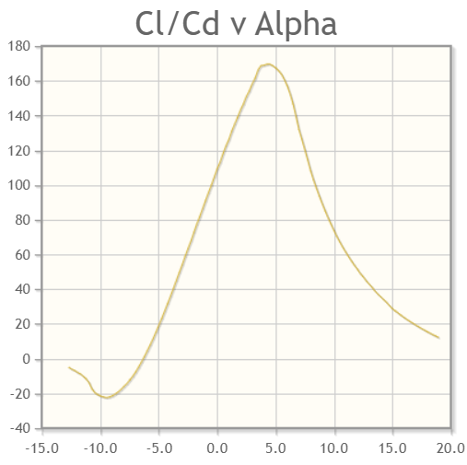

*Figure 7.29 Graph α Vs CL \CD*

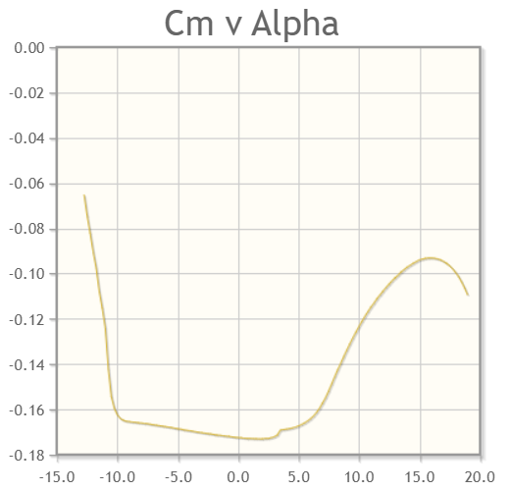

*Figure 7.30 Graph α Vs Cm*

**7.5 WING SETTING ANGLE**

The wing setting angle for business jets are generally between, 0-10

The selected wing setting angle for our aircraft, αset = 0.50

**7.6 ASPECT RATIO**

The aspect ratio is selected from **Chapter 4 – 4.1.1** in the tentative parameters.

The Aspect ratio for our aircraft, A.R. = 7.043

**7.7 WING AREA (S)**

The wing area is selected from **Chapter 4 – 4.1.1** in the tentative parameters.

The wing area for our aircraft, S = 430 m2

**7.8 WING SPAN (b)**

The wing span is calculated from the formula,

* b = 55 m

**7.9 TAPER RATIO (λ)**

The taper ratio for a delta wing is 0

**7.10 C Root**

The Chord root is given by the formula,

Where, λ is the Taper ratio

* C Root = 15.63 m

**7.11 C Tip**

The Chord tip is given by the formula,

Where, λ is the Taper ratio

* C Tip = 0 m

**7.12 C Mean**

The Chord mean is given by the formula,

Where, λ is the Taper ratio

* C Mean = 10.42 m

**7.13 CL**

The wing lift coefficient is given by the formula,

Where, W is the Take-Off weight

ρ is the Density at cruise altitude

V is the Cruise velocity

S is the Wing area

* CL = 0.02430

**7.14 CONCLUSION**

*Table 7.3 Selected Wing Parameters*

|  |  |
| --- | --- |
| **Name** | **Parameters** |
| Wing setting angle | 0.50 |
| Aspect Ratio | 7.043 |
| Wing Area | 430 m2 |
| Wing Span | 55 m |
| Taper Ratio | 0 |
| CRoot | 15.63 m |
| CTip | 0 m |
| CMean | 10.42 m |
| CL | 0.02430 |

**7.15 WING OUTLINE**

**7.15.1 Air foil:**

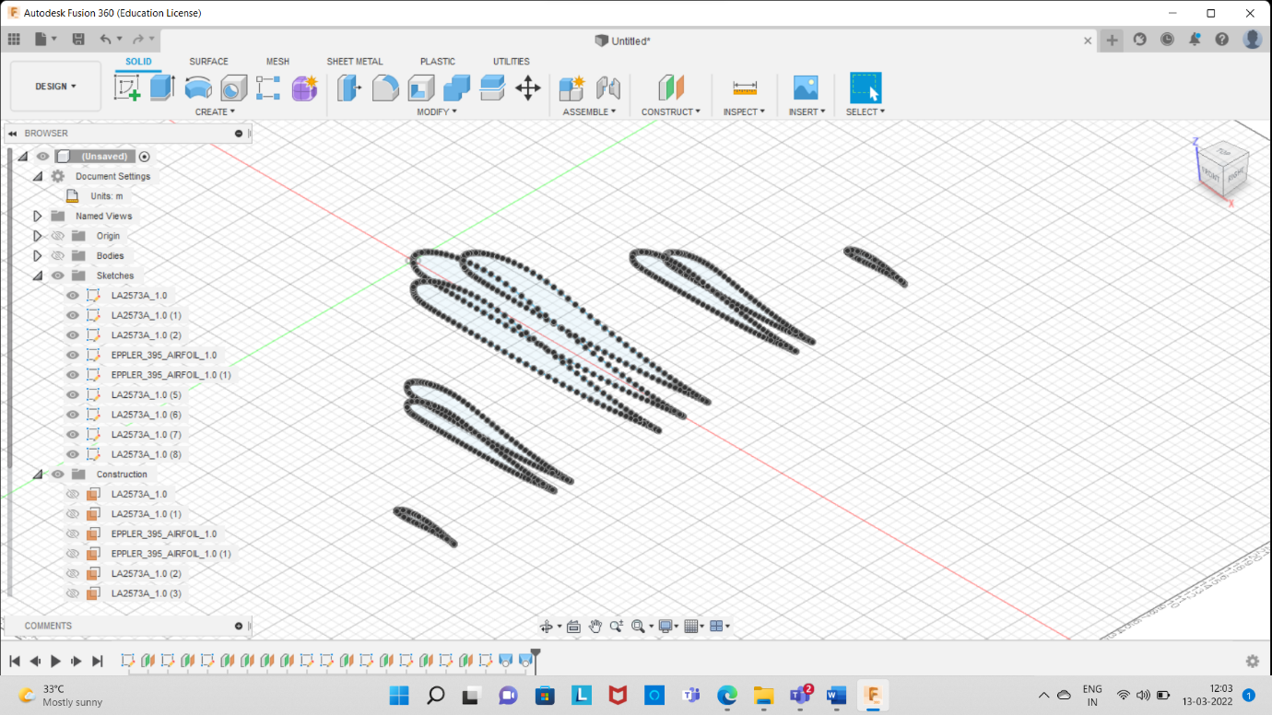

*Figure 7.31 Air foil Outline*

**7.15.2 Isometric View:**

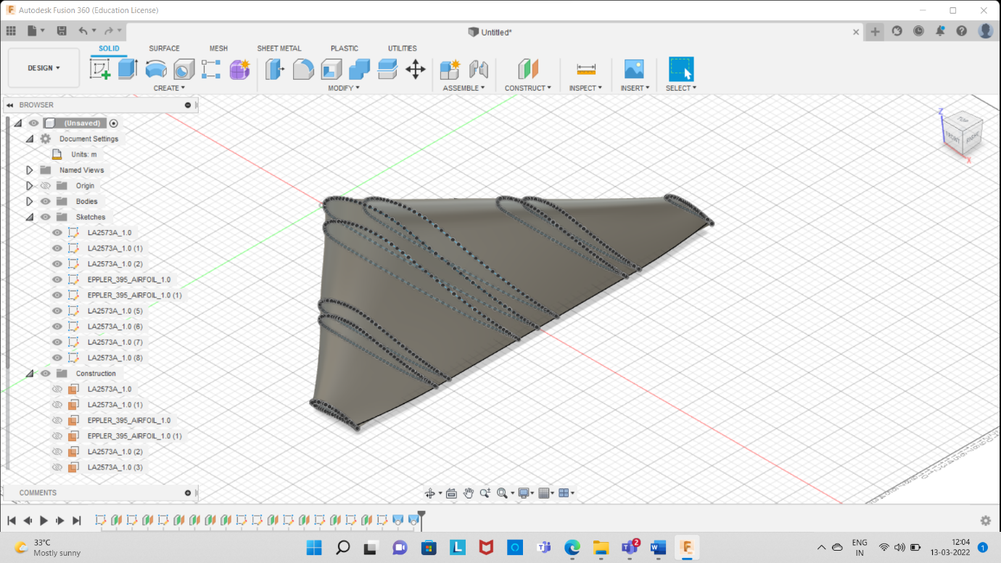

*Figure 7.32 Isometric View*

**7.15.3 Top View:**

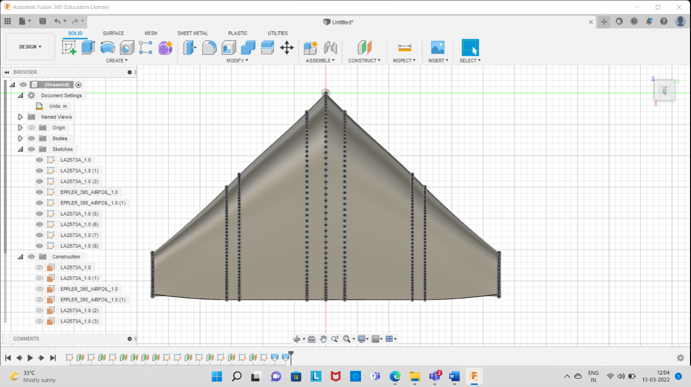

*Figure 7.33 Top View*

**7.15.4 Side View:**

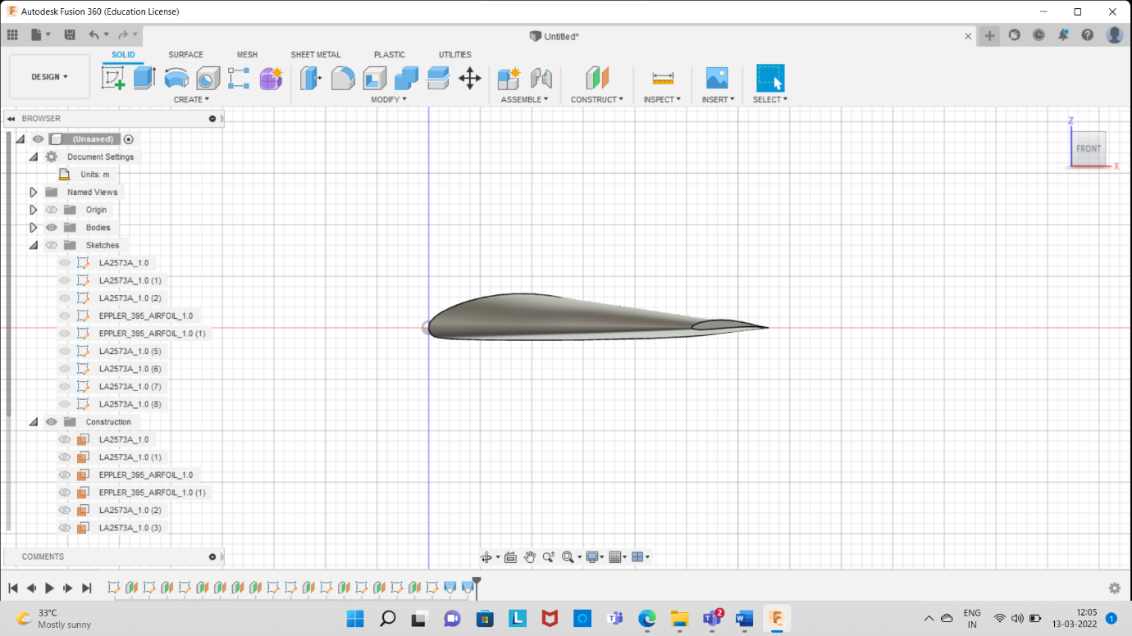

*Figure 7.34 Top View*

**7.16 LIFT AND PRESSURE DISTRIBUTION**

**7.16.1 Liebeck LA2537 A**

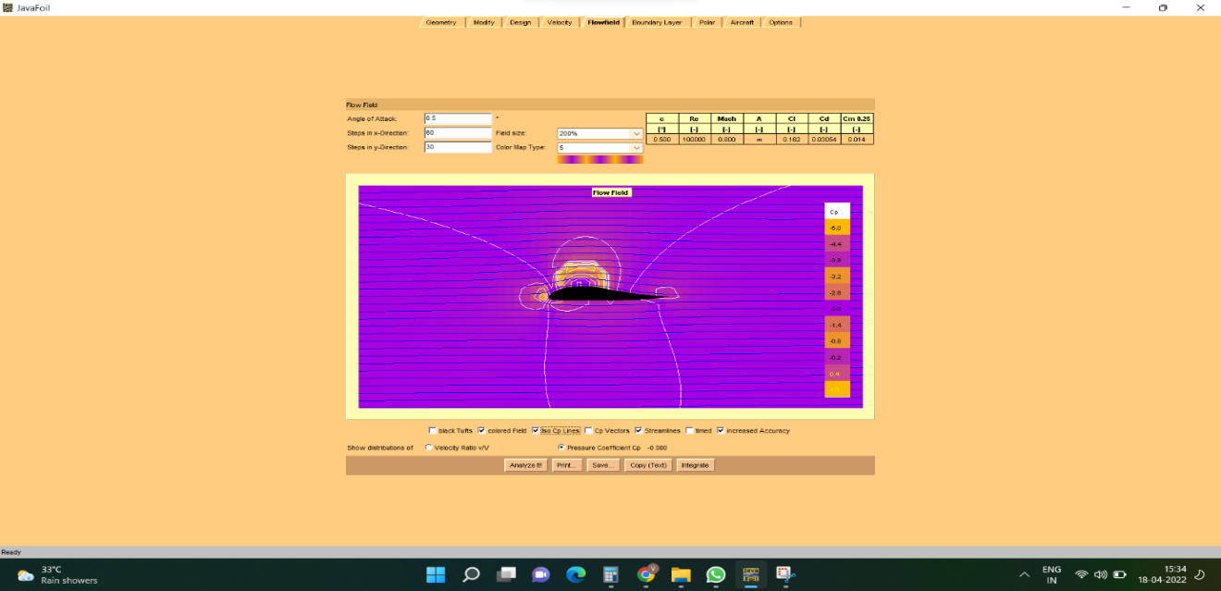

*Figure 7.35 Pressure Distribution in Air foil with Vectors for Liebeck LA2537 A*

Figure 7.35 shows the pressure distribution with vectors on Liebeck LA2537 A and shows that pressure is more in the top and lesser in the bottom

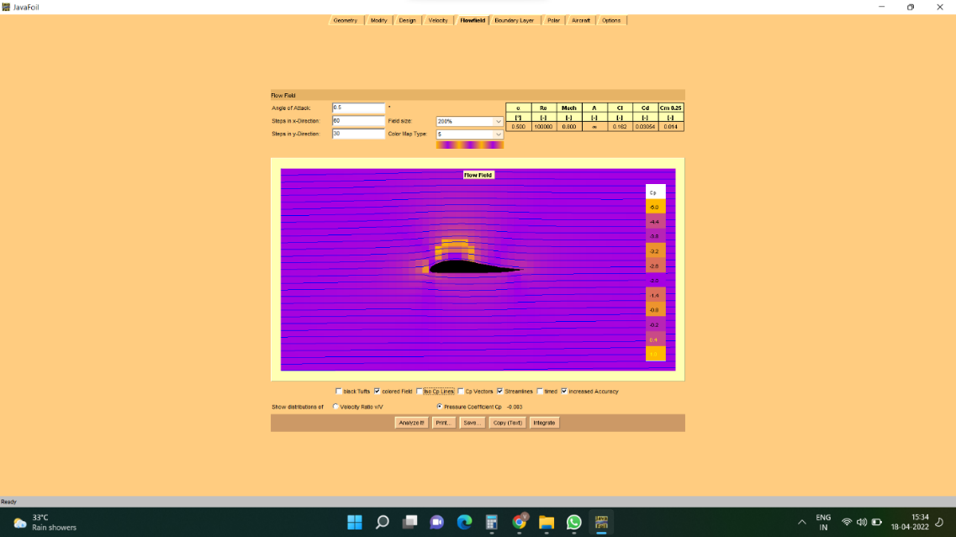

*Figure 7.36 Pressure Distribution Liebeck LA2573 A*

Figure 7.36 shows the pressure distribution on Liebeck LA 2573 A without vectors and the pressure is higher in the top and lesser in the bottom

**7.16.2 Eppler 395**

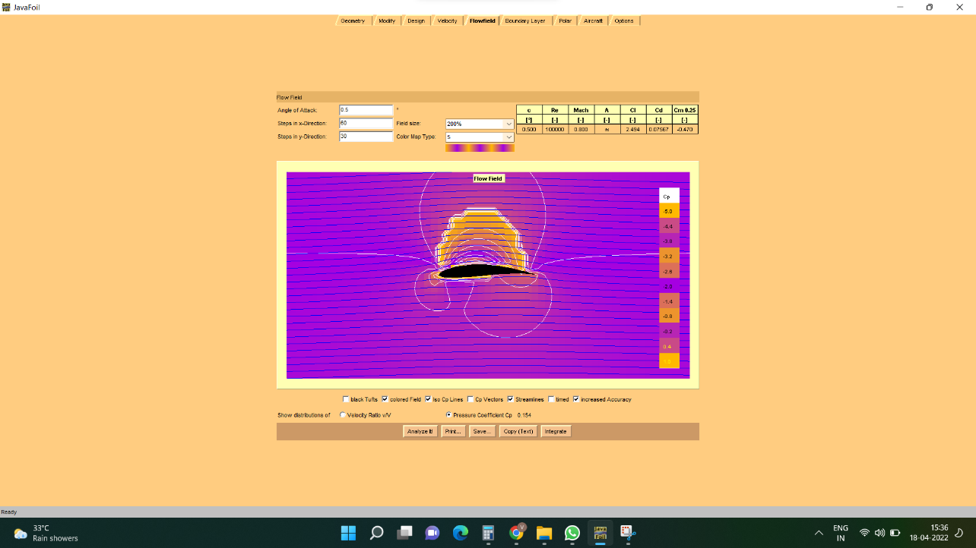

*Figure 7.37 Lift Distribution on Eppler 395*

Figure 7.37 shows the pressure distribution with vectors on Eppler 395 and shows that pressure is more in the top and lesser in the bottom

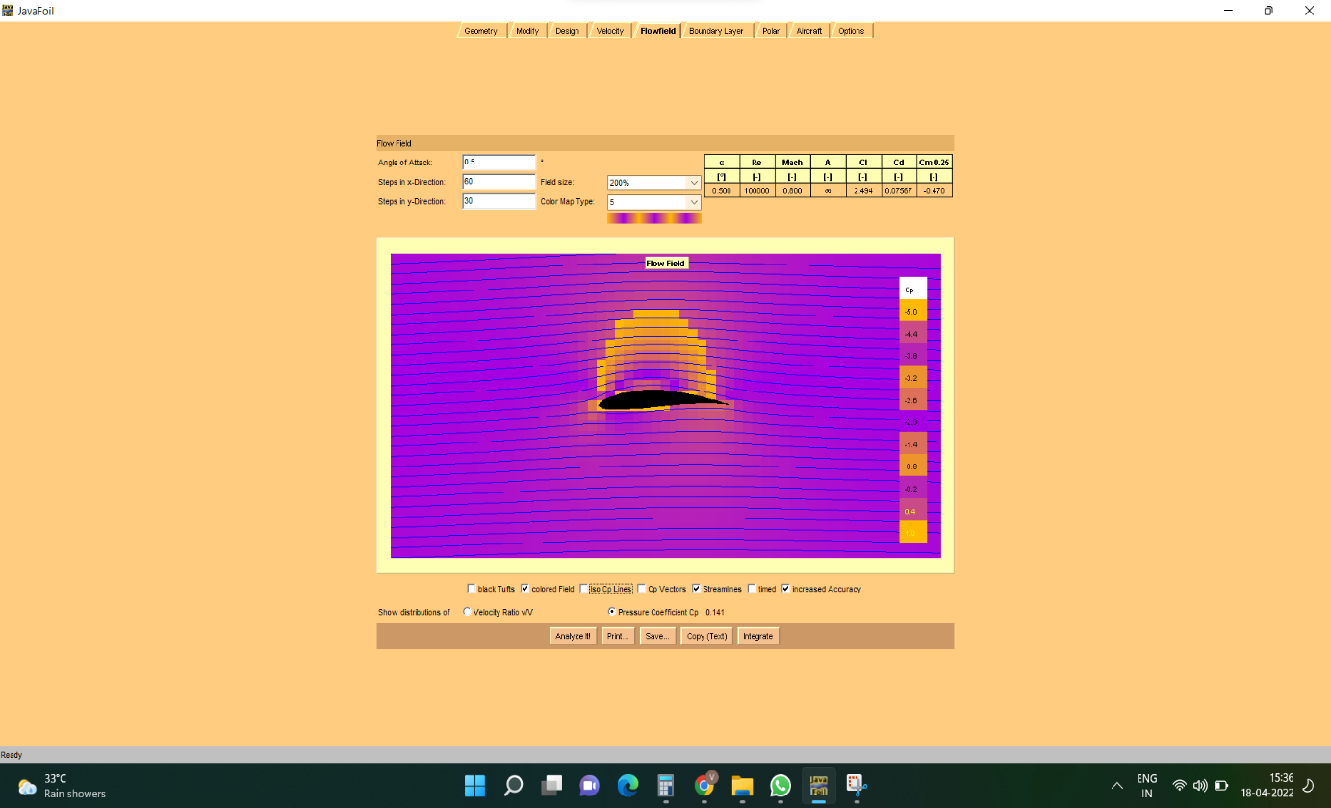

*Figure 7.38 Pressure Distribution on Eppler 395*

Figure 7.38 shows the pressure distribution on Liebeck LA 2573 A without vectors and the pressure is higher in the top and lesser in the bottom.

**CHAPTER 8**

**TAIL PLANE SELECTION**

**8.1 TAIL PLANE SELECTION**

A tail plane, also known as a horizontal stabilizer, is a small lifting surface located on the tail (empennage) behind the main lifting surfaces of a fixed-wing aircraft. The tail plane of an aircraft is classified as follows,

Conventional Tail

T – Tail

V – Tail

Inverted V – Tail

Cruciform Tail

Tailless

Y- Tail

H-Tail

Twin Boom

**8.1.1 CONVENTIONAL TAIL**

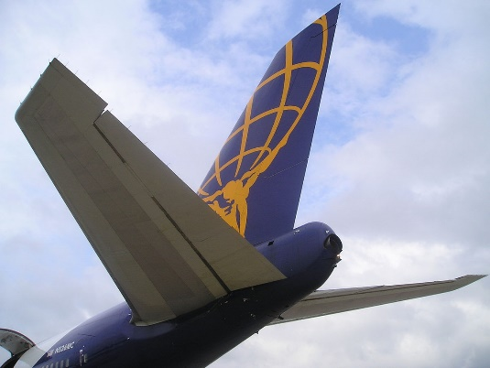 The conventional tail design is the most common form. It has one vertical stabilizer placed at the tapered tail section of the fuselage and one horizontal stabilizer divided into two parts, one on each side of the vertical stabilizer. For many airplanes, the conventional arrangement provides adequate stability and control.

*Figure 8.1 CONVENTIONAL TAIL*

**8.1.2 T - TAIL**

The horizontal stabilizer is mounted on top of the fin, creating a "T" shape when viewed from the front. T-tails keep the stabilizers out of the engine wake, and give better pitch control. T-tails have a good glide ratio, and are more efficient on low speed aircraft.

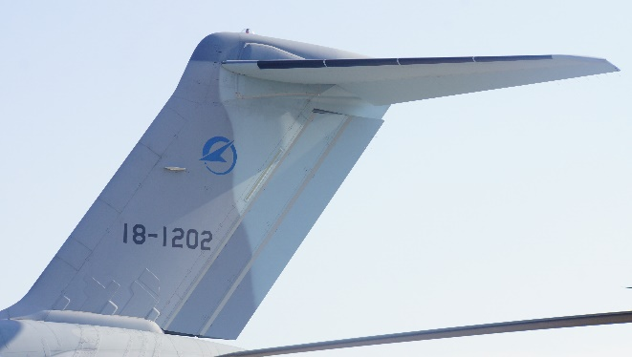

*Figure 8.2 T - TAIL*

**8.1.3 V - TAIL**

A V-tail can be lighter than a conventional tail in some situations and produce less drag. A V-tail may also have a smaller radar signature.

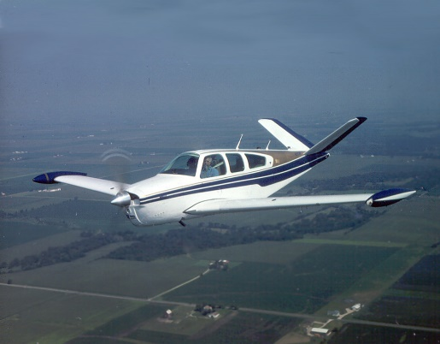

*Figure 8.3 V - TAIL*

**8.1.4 INVERTED TAIL**

The inverted V-tail is similar to V-tail but it is inverted and it provides more stability and manoeuvrability. It is mostly used in Unmanned Aerial Vehicles.

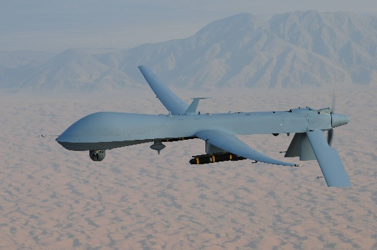

*Figure 8.4 Inverted V - TAIL*

**8.1.5 CRUCIFORM TAIL**

The horizontal stabilizers are placed midway up the vertical stabilizer, giving the appearance of a cross when viewed from the front. Cruciform tails are often used to keep the horizontal stabilizers out of the engine wake, while avoiding many of the disadvantages of a T-tail.

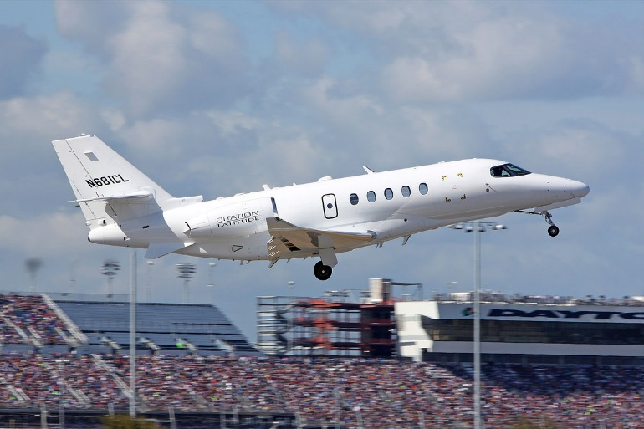

*Figure 8.5 CRUCIFORM TAIL*

**8.1.6 TAILLESS**

A tailless aircraft has no tail assembly and no other horizontal surface besides its main wing. The aerodynamic control and stabilization functions in both pitch and roll are incorporated into the main wing. A tailless type may still have a conventional vertical fin (vertical stabilizer) and rudder.

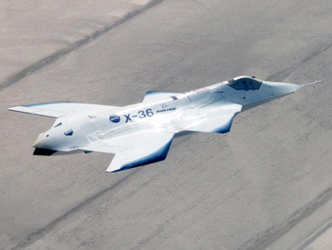

*Figure 8.6 TAILLESS*

**8.1.7 Y-TAIL**

A V-tail with an added lower vertical fin generally used to protect an aft propeller.

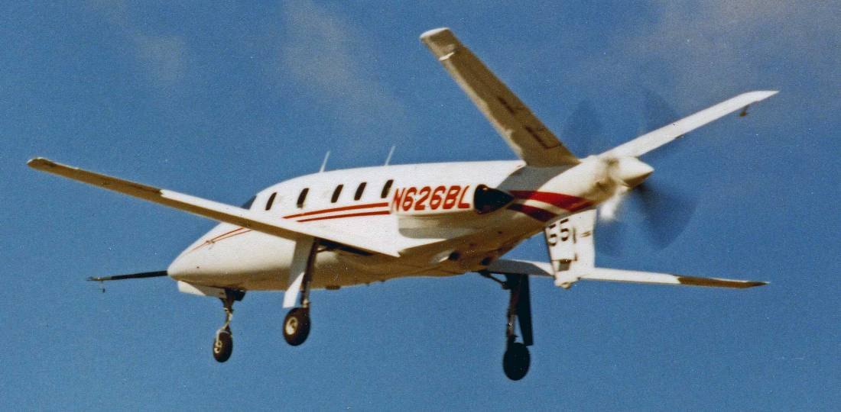

*Figure 8.7 Y-TAIL*

**8.1.8 H-TAIL**

A **twin tail** is a specific type of vertical stabilizer arrangement found on the empennage of some aircraft. Two vertical stabilizers—often smaller on their own than a single conventional tail would be—are mounted at the outside of the aircraft's horizontal stabilizer. This arrangement is also known as an **H-tail.**

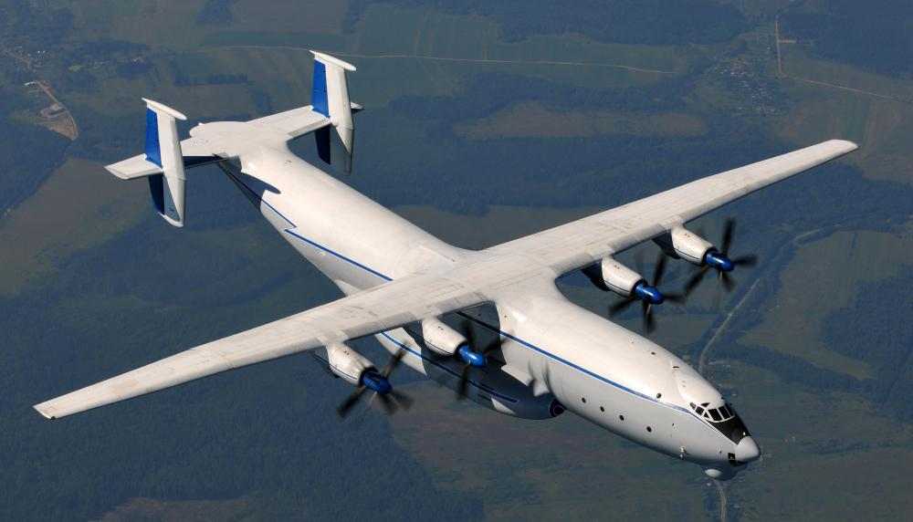

*Figure 8.8 H-TAIL*

**8.1.9 TWIN BOOM**

A **twin-boom aircraft** is characterised by two longitudinal booms (extended nacelle-like bodies). The booms may contain ancillary items such as fuel tanks and/or provide a supporting structure for other items.

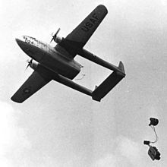

*Figure 8.9 TWIN BOOM*

**SELECTION:**

The **Tailless** empennage is selected for the aircraft due to the following advantages,

* **low parasitic drag**
* **soaring glider and good stealth characteristics**

But the aircraft has a rudder connected with a vertical stabilizer to help ease pilot’s work and to provide yaw motion. The pitching and rolling motion are provided by the elevons attached in the wing.

**CHAPTER 9**

**POWERPLANT SELECTION**

**9.1 ENGINE SELECTION**

The engine in an aircraft plays a major role as it generates thrust for the aircraft to take-off and move forward. The engines are classified based on their working methods as follows,

Reciprocating Engine

Turbojet Engine

Turbofan Engine

Turboprop Engine

Ramjet Engine

Scramjet Engine

Pulsejet Engine

**9.1.1 RECIPROCATING ENGINE**

A reciprocating engine, also often known as a Piston engine, is typically a heat engine. Uses one or more reciprocating pistons to convert pressure into a rotating motion. There may be one or more pistons. Each piston is inside a cylinder, into which a gas is introduced, either already under pressure or heated inside the cylinder either by ignition of a fuel air mixture or by contact with a hot heat exchanger in the cylinder. The linear movement of the piston is converted to a rotating movement via a connecting rod and a crankshaft or by a swashplate or other suitable mechanism.

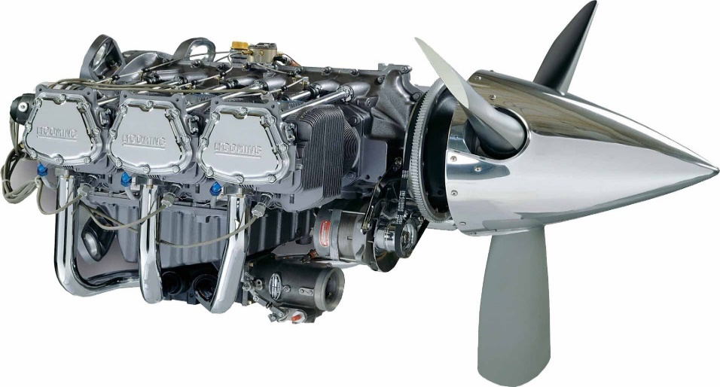

*Figure 9.1 RECIPROCATING ENGINE*

**9.1.2 TURBOJET ENGINE**

A turbojet engine is a jet engine which produces all of its thrust by ejecting a high energy gas stream from the engine exhaust nozzle. In contrast to a turbofan or bypass engine, 100% of the air entering the intake of a turbojet engine goes through the engine core. Air is drawn into the engine through the inlet and compressed and heated by the compressor. Fuel is then added in the combustion chamber and ignited. The burning fuel adds energy to the exhaust stream by heating and expanding the air. Sufficient energy to drive the compressor is extracted from the exhaust stream by the turbine.

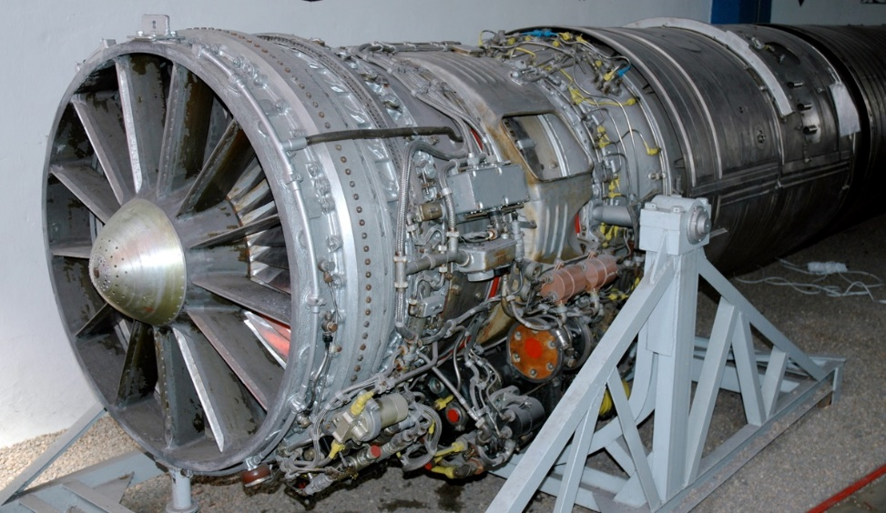

*Figure 9.2 TURBOJET ENGINE*

**9.1.3 TURBOFAN ENGINE**

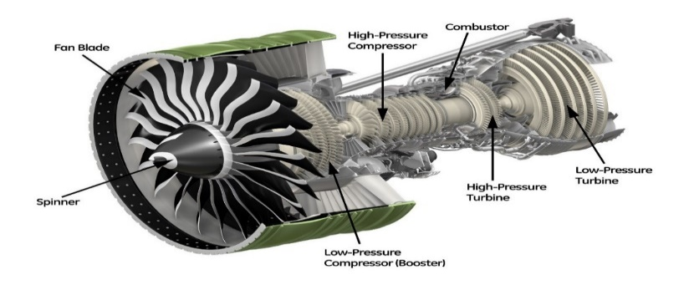 A Turbofan engine is the most modern variation of the basic gas turbine engine. As with other gas turbines, there is a core engine. In the turbofan engine, the core engine is surrounded by a fan in the front and an additional turbine at the rear. The fan and fan turbine are composed of many blades, like the core compressor and core turbine, and are connected to an additional shaft.

*Figure 9.3 TURBOFAN ENGINE*

**9.1.4 TURBOPROP ENGINE**

A turboprop engine is a turbine engine that drives an aircraft propeller. In its simplest form a turboprop consists of an intake, compressor, combustor, turbine, and a propelling nozzle.

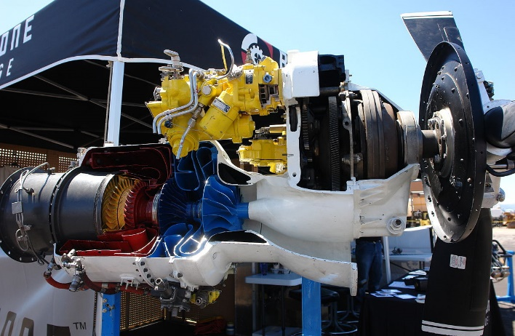

*Figure 9.4 TURBOPROP ENGINE*

**9.1.5 RAMJET ENGINE**

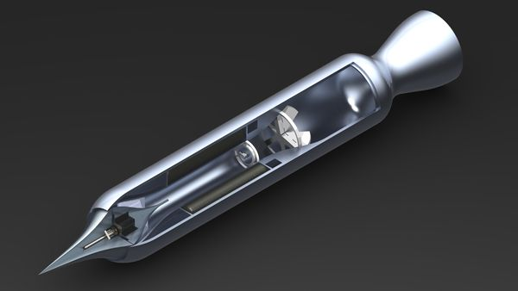 A ramjet, sometimes referred to as a flying stovepipe or an athodyd, is a form of air breathing jet engine that uses the engine's forward motion to compress incoming air without an axial compressor or a centrifugal compressor.

*Figure 9.5 RAMJET ENGINE*

**9.1.6 SCRAMJET ENGINE**

A scramjet is a variant of a ramjet air breathing jet engine in which combustion takes place in supersonic airflow. Scramjet relies on high vehicle speed to compress the incoming air forcefully before combustion (hence ramjet), but whereas a ramjet decelerates the air to subsonic velocities before combustion, the airflow in a scramjet is supersonic throughout the entire engine.

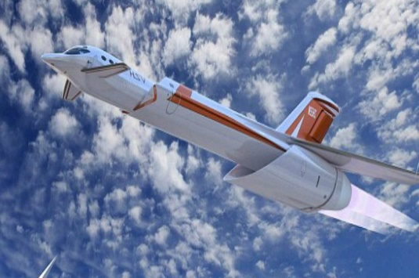

*Figure 9.6 SCRAMJET ENGINE*

**9.1.7 PULSEJET ENGINE**

A scramjet is a variant of a ramjet air breathing jet engine in which combustion takes place in supersonic airflow. Scramjet relies on high vehicle speed to compress the incoming air forcefully before combustion (hence ramjet), but whereas a ramjet decelerates the air to subsonic velocities before combustion, the airflow in a scramjet is supersonic throughout the entire engine.

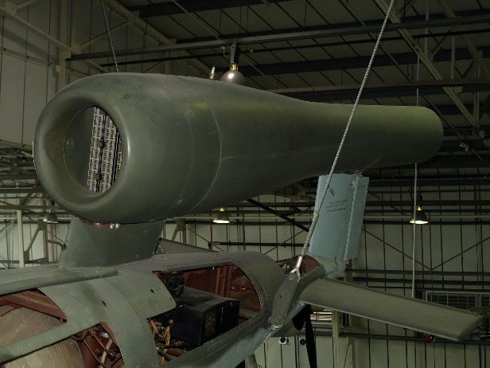

*Figure 9.7 PULSEJET ENGINE*

**SELECTION:**

The **Turbojet Engine** will be mounted in our aircraft. It has the following advantages compared to other engines,

* It has much higher power to weight ratio than the piston engine.
* Turbojet engine can operate at very high temperatures.
* It can produce more thrust than the propeller engine.
* Mating parts are less so less wear.
* Low grade fuel can be used.

**9.2 ENGINE THRUST**

The thrust produced by the engine is selected from the table. The selected Thrust for the engine is 110 kN

*Table 9.1 Engine Data*

|  |  |  |
| --- | --- | --- |
| **Aircraft\Data** | **Type of engine/Power plant** | **Thrust** |
| **Northrop**  **YB-49** | 8 × Allison J35-A-15 turbojet engines | 18 kN each |
| **Lockheed**  **A-12** | 2 × Pratt & Whitney JT11D-20B (J58-1) Afterburning turbojet | 91 kN each |
| **Lockheed**  **SR-71 Blackbird** | 2 × Pratt & Whitney J58 (JT11D-20J or JT11D-20K) Afterburning turbojets | 110 kN each |

The chosen engine is **Pratt & Whitney J58 Afterburning turbojet engines**

|  |  |
| --- | --- |
| **Data** | **Parameters** |
| **Thrust** | 110 kN |
| **Length** | 4.6 m |
| **Diameter** | 1.3 m |
| **Dry Weight** | 2700 kg |
| **Specific Fuel Consumption** | 54 g/(kN⋅s) |
| **Thrust to Weight Ratio** | 5.23 |

*Table 9.2 Engine Performance Data*

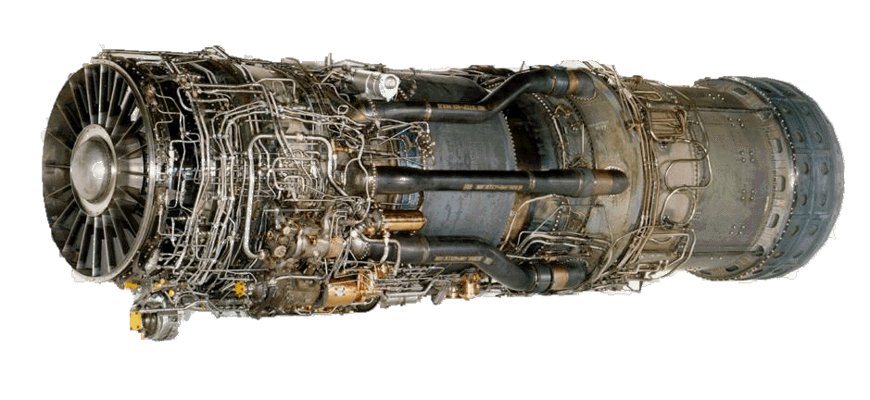

*Figure 9.8* *Pratt & Whitney J58**Engine*

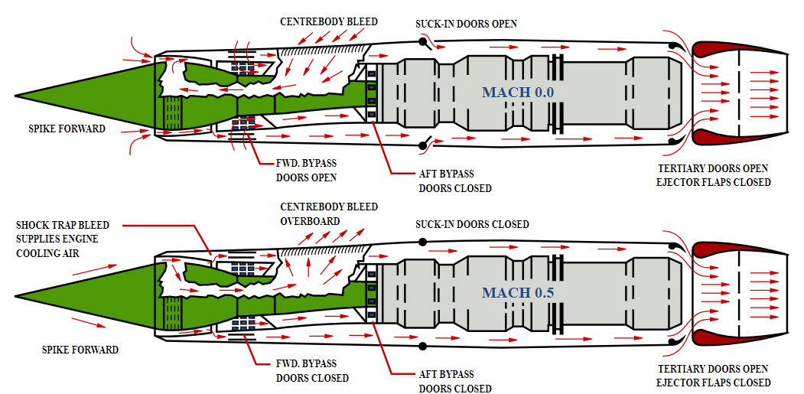

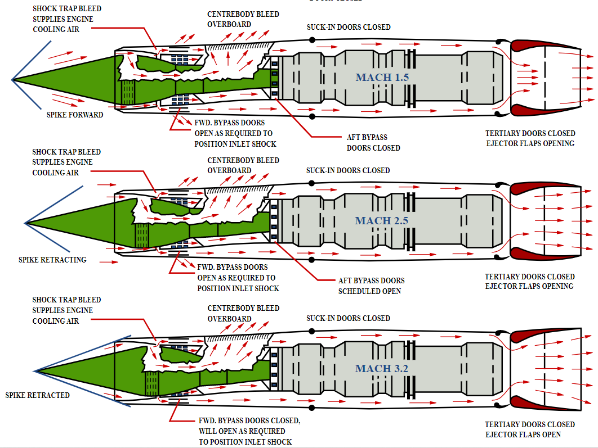

*Figure 9.9 Working of the Pratt & Whitney J58**Engine*

**9.3 ENGINE LOCATION**

The engine is mounted in the wing body. It gives the following advantages,

* It reduces drag.
* It gives us the freedom to develop complicated wing designs.

**9.4 NUMBER OF ENGINES**

The aircraft has 2 engines at the symmetry of the blended wing section. It is a twin-engine aircraft.

**CHAPTER 10**

**LANDING GEAR SELECTION**

Landing gear is the undercarriage of an aircraft or spacecraft and may be used for either take-off or landing. For aircraft it is generally both. For aircraft, the landing gear supports the craft when it is not flying, allowing it to take off, land, and taxi without damage.

**10.1 LANDING GEAR TYPES**

The landing gears are classified as follows,

Fixed

Retractable

**10.1.1 Fixed Landing Gear**

Landing gear employing a rear-mounted wheel is called fixed landing gear. Fixed gear is designed to simplify design and operation. The advantages are that it is always deployed and its initial instalments cost is low. Whereas its disadvantage is that produces constant drag.

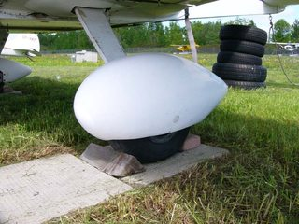

*Figure 10.1 FIXED LANDING GEAR*

**10.1.2 Retractable Landing Gear**

A retractable gear is designed to streamline the airplane by allowing the landing gear to be stowed inside the structure during cruising flight. Retractable landing gear systems may be operated either hydraulically or electrically, or may employ a combination of the two systems.

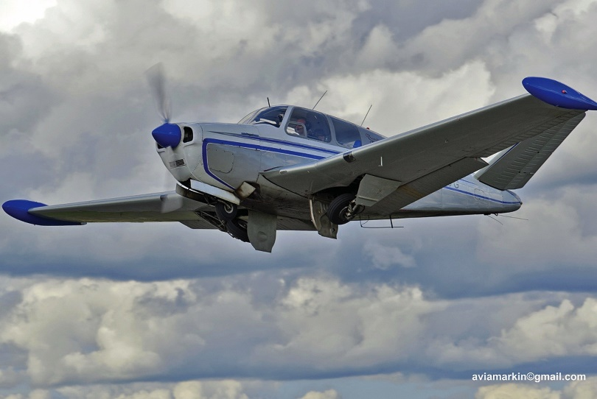

*Figure 10.2 RECTRACTABLE LANDING GEAR*

**SELECTION:**

The **Retractable landing gear** is implemented in the aircraft due to the following reasons,

* There will be less drag during cruise as the landing gear will be retracted.
* It helps in higher cruise speeds and increased climb performance.

**10.2 LANDING GEAR CONFIGURRATIONS**

The landing gears have different configurations based on the number of wheels and their arrangement. They are classified as follows,

1. Single wheel
2. Bicycle
3. Tricycle
4. Quadricycle
5. Multi-bogey

**10.2.1 Single wheel Landing Gear**

The single-wheel configuration, defined as a main gear of having a total of two wheels, one on each strut, the dual-wheel configuration, defined as a main gear of having a total of four wheels, two on each strut, and the dual-tandem configuration, defined as two sets of wheels on each strut.

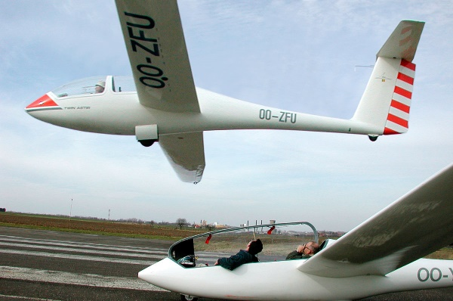

*Figure 10.3 SINGLE WHEEL LANDING GEAR*

**10.2.2 Bicycle**

A relatively uncommon landing gear option is the bicycle undercarriage. Bicycle gear features two main gear along the centreline of the aircraft, one forward and one aft of the centre of gravity. Preventing the plane from tilting over sideways are two small outrigger gear mounted along the wing.

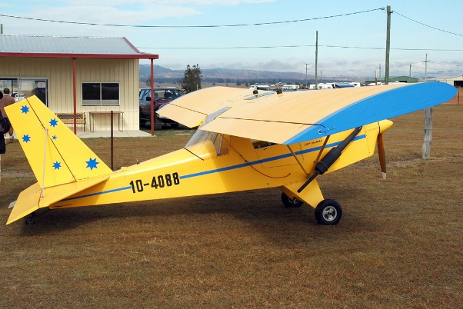

*Figure 10.4 BICYCLE*

**10.2.3 Tricycle**

The most commonly used landing gear arrangement is the tricycle-type landing gear. It is comprised of main gear and nose gear. Tricycle-type landing gear is used on large and small aircraft. It allows more forceful application of the brakes without nosing over when braking, which enables higher landing speeds.

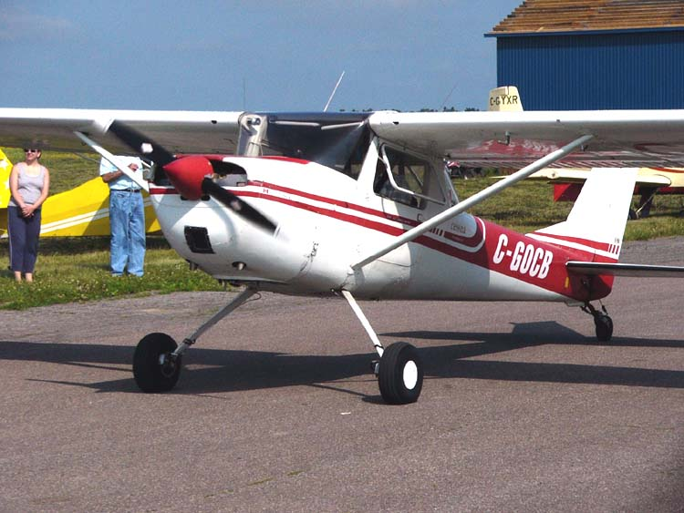

*Figure 10.5 TRICYCLE*

**10.2.4 Quadricycle**

Quadricycle gear are also very similar to the bicycle arrangement except there are four main gear roughly equal in size and mounted along the fuselage. Like bicycle gear, the Quadricycle undercarriage also requires a very flat attitude during take-off and landing. This arrangement is also very sensitive to roll, crosswinds, and proper alignment with the runway.

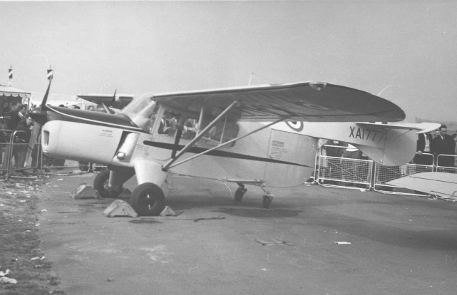

*Figure 10.6 QUADRICYCLE*

**Multi-bogey**

A final variation that is worth mentioning is the use of multiple wheels per landing gear strut. This additional tire is particularly useful on carrier-based aircraft where two nose wheels are a requirement. Multiple wheels are also often used on main gear units for added safety, especially on commercial airliners.

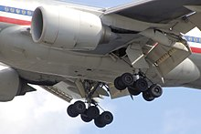

*Figure 10.7 MULTI-BOGEY*

**SELECTION:**

The **Tricycle retractable landing gear** configuration is implemented for the following reasons,

* It allows more forceful application of the brakes without nosing over when braking, which enables higher landing speeds.
* It provides the advantage of giving more vision to the pilot.

**CHAPTER 11**

**FUSELAGE SELECTION**

**11.1 FUSELAGE SELECTION**

The fuselage construction plays a major role in reducing the total weight of the aircraft. The fuselage construction of an aircraft is classified as follows,

Monocoque

Semi-Monocoque

Geodesic

**11.1.1 MONOCOQUE**

The Monocoque (single shell) fuselage relies largely on the strength of the skin or covering to carry the primary loads. Monocoque construction uses stressed skin to support almost all loads much like an aluminium beverage can. Because most twisting and bending stresses are carried by the external skin rather than by an open framework, the need for internal bracing was eliminated or reduced, saving weight and maximizing space.

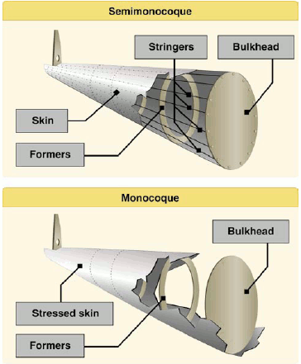

*Figure 9.1 MONOCOQUE*

**11.1.2 SEMI-MONOCOQUE**

To overcome the strength/weight problem of Monocoque construction, a modification called semi Monocoque construction was developed. It also consists of frame assemblies, bulkheads, and formers as used in the Monocoque design but, additionally, the skin is reinforced by longitudinal members called longerons.



*Figure 9.2 SEMI-MONOCOQUE*

**11.1.3 GEODESIC TRUSS**

Geodesic airframe is a type of construction for the airframes of aircraft developed by British aeronautical engineer Barnes Wallis in the 1930s. It makes use of a space frame formed from a spirally crossing basket-weave of load -bearing members. The principle is that two geodesic arcs can be drawn to intersect on the fuselage in a manner that the torsional load on each cancel out that on the other.

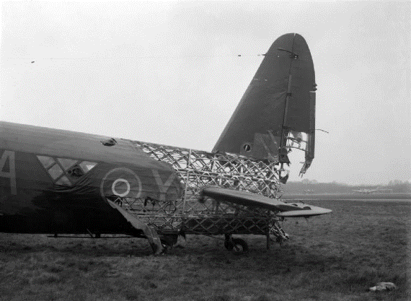

*Figure 9.3 GEODESIC TRUSS*

**SELECTION:**

The **Semi-Monocoque** fuselage is constructed for the following advantages,

* The Semi-Monocoque structure is less in weight compared to Truss structures.
* The stringers and longerons are light in weight while it provides high strength.
* The skin of the fuselage is supported by bulkheads and other structures.

**CHAPTER 12**

**LIFT AND DRAG ESTIMATION**

**12.1 LIFT CALCULATION**

**12.1.1 LIFT AT CRUISE**

The lift at cruise is given by the formula,

Where, ρ is the density at cruising altitude

V is the cruising velocity

CL is the Coefficient of lift

* L= 3791548.634 N



**12.1.2 LIFT AT TAKE-OFF**

The lift at take-off is given by the formula,

Where, ρ is the density at sea level

V = 0.7 * 1.2 * V Stall

CL is the Maximum Coefficient of lift

* V = 0.7 * 1.2 * 51.34
* V = 43.13 m/s
* L= 636908.166 N

**12.1.3 LIFT AT LANDING**

The lift at landing is given by the formula,

Where, ρ is the density at sea level

V = 0.7 * 1.3 * V Stall

CL is the Minimum Coefficient of lift

* V = 0.7 * 1.3 * 51.34
* V = 46.72 m/s
* L= 373674.59N

**12.2 DRAG CALCULATION**

**12.2.1 DRAG AT CRUISE**

The Drag at cruise is given by the formula,

Where, b is the wing span

h is the wing from ground

CD, 0 = 0.0030

* D= 207076.88N

**12.2.2 DRAG AT TAKE-OFF**

The drag at take-off is given by the formula,

Where, ρ is the density at sea level

V = 0.7 * 1.2 * V Stall

CL is the Maximum Coefficient of lift

* D= 34784.98 N

**12.2.3 DRAG AT LANDING**

The drag at landing is given by the formula,

Where, ρ is the density at sea level

V = 0.7 * 1.3 * V Stall

CL is the Minimum Coefficient of lift

CD = 0.0030

* D= 11497.67 N

**12.3 CONCLUSION**



*Table 11.1 Calculated Lift and Drag Data*

|  |  |  |
| --- | --- | --- |
| **Conditions** | **Lift**  (kg/m s2) | **Drag**  (kg/m s2) |
| **Cruise** | 3791548.634 | 207076.88 |
| **Take-off** | 636908.166 | 34784.98 |
| **Landing** | 373674.59 | 11497.67 |

**CHAPTER 13**

**PERFORMANCE CALCULATION**

**13.1 RATE OF CLIMB**

The Rate of Climb is given by the formula,

Where, VStall = 51.34 m/s  
 WTo = 65000 kg

D = 34784.98 N

T = 220000 N

* = 14.93 m/s

**13.2 GLIDING ANGLE**

The Gliding Angle is given by the formula,

Where, (L/D)Max = 18.549

* = 3.080

**13.3 TAKE-OFF DISTANCE CALCULATION**

The Take-Off distance is given by the formula,

Where, VLO = 1.2 * VStall  
 T= Mean Design Parameter

W = WTO

D = DTO

L = LTO

ρ = Density at sea level

µr = Coefficient of friction between tyres and ground

**13.4 LANDING PERFORMANCE**

The Landing performance is given by the formula,

Where, VLO = 1.2 * VStall  
 T= Mean Design Parameter

W = Landing Weight

D = Landing Drag

L = LTO

ρ = Density at sea level

µr = Coefficient of friction between tyres and ground

**13.5 CONCLUSION**

*Table 12.1 Performance Parameters*

|  |  |
| --- | --- |
| **Data** | **Parameters** |
| **Rate of Climb** | 14.93m/s |
| **Gliding Angle** | 3.080 |
| **Take-Off Distance** | m |
| **Landing Performance** | m |

**CHAPTER 14**

**3 VIEW DIAGRAM**

**14.1. TOP VIEW**

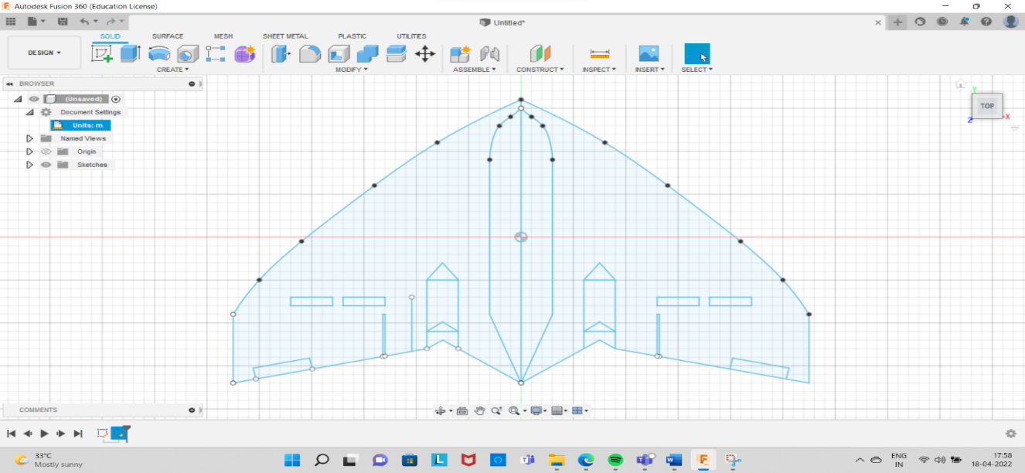

*Figure 14.1 Top View*

Figure 14.1 shows the top view of the blended wing aircraft with twin fuselage

**14.2. FRONT VIEW**

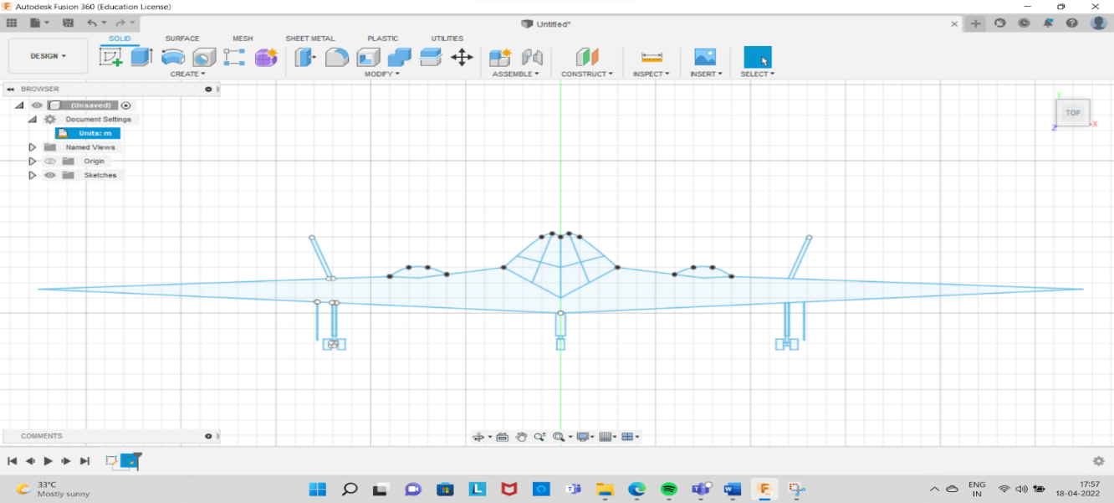

*Figure 14.2 Front View*

Figure 14.2 shows the front view of the blended wing aircraft with twin fuselage

**14.3. LEFT-SIDE VIEW**

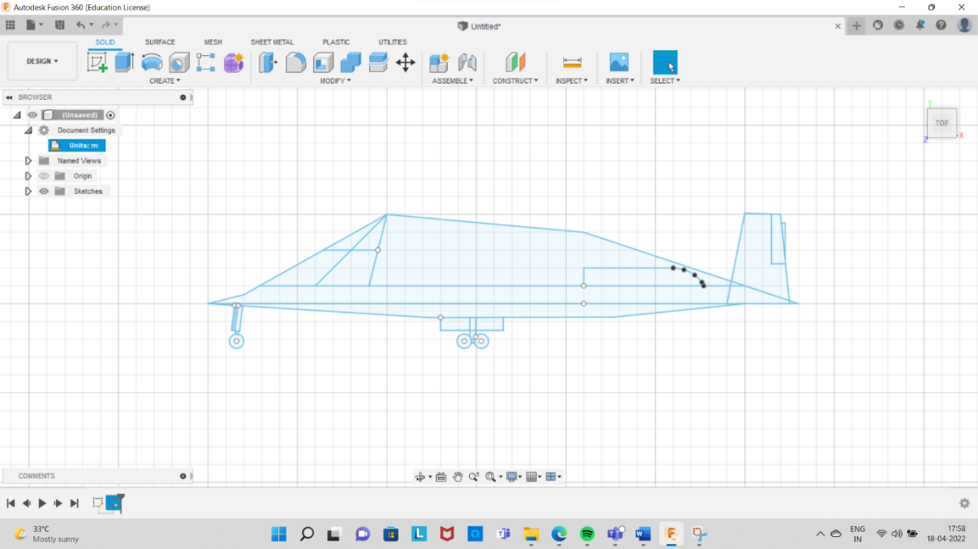

*Figure 14.2 Left-Side View*

Figure 14.3 shows the left-side view of the blended wing aircraft with twin fuselage

**Conclusion**

The preliminary design of a twin fuselage blended wing bomber has been developed based on systematic calculations and appropriate references. The design may not fulfil the requirements of an actual aircraft, it is completely a conceptual design. The design is always subjected to changes and implementation. All the parameters for the design of aircraft are completely obtained out of calculations.

This design consists of two major advantage factors; it has a blended wing body which accounts for high lift characteristics and very good take-off and landing performances. This enables us to reduce the effort taken during take-off thus, being more effective. The other advantage is that it is a twin fuselage aircraft which can give more cargo space and bomb sheltering space.

**Future Works**

The following are the future works of the same project,

* Preliminary design of the aircraft wing – Shrenck’s Curve, Structural Load Distribution, Shear force, Bending Moment and Torque Diagrams
* Detailed design of an aircraft wing – Design of Spars and Stringers, Bending Stress and Shear flow Calculations, Buckling analysis of fuselage panels.
* Preliminary Design of an aircraft fuselage – Load Distribution on an aircraft fuselage
* Detailed design of an aircraft fuselage – Design of bulkheads and longerons, bending stress and shear flow calculations, buckling analysis of fuselage panels.
* Design of control surfaces – Balancing and manoeuvring loads on the tail plane and aileron, rudder loads.
* Design of Wing-root attachment
* Preparation of a detailed design report with CAD drawings.

**References**

|  |  |
| --- | --- |
| 1 | John D Anderson, *Introduction to flight,* 2nd Edition. ISBN: 9780073380247 |
| 2 | Daniel P Raymer, *Aircraft Design: A conceptual approach.* 4th Edition, ISBN: 101600869114 |
| 3 | Ira H. Abbott, *Theory of wing sections,* Dover Edition, ISBN-10 : 0486605868 |
| 4 | Joaquim R R A Martins , *Aircraft design via numerical optimization, Journal*  *of aeronautics and aerospace engineering , conference proceedings*, DOI:  10.4172/2168-9792-C2-025 |
| 8 | https://www.engineeringtoolbox.com/standard-atmosphere-d_604.html |
| 9 | http://www.airfoiltools.com |
| 10 | http://www.airfoildb.com |
| 11 | https://www.nasa.gov/pdf/89232main_TF-2004-13-DFRC.pdf |
| 12 | Preliminary Design of Blended Wing Body Passenger Aircraft for Long Range by RANDHIR BRAR (Approved for the Department of Aerospace Engineering, San Jose State University, May 2014) |

**ABOUT THE AUTHOR**

|  |  |
| --- | --- |
|  | Jefran Calvin J  Chennai, Tamil Nadu, INDIA  I am pursuing my B.Tech degree in Aerospace Engineering in Hindustan Institute of Technology and Science. I am educated in various branches of Aerospace such as Structures, Propulsion, Aerodynamics, Design and Simulation. I have good knowledge in Fusion 360 and ANSYS I have participated in conferences and workshops and have been student intern in various companies and helped them designing a Re-Entry Capsule and Plunger Components and analyze them. I am very interested in small satellites and can satellites. |
|  | Sanju Mallick  Chennai, Tamil Nadu, INDIA  I am pursuing B.Tech Aerospace Engineering in Hindustan Institute of Technology and Science. During my period I have acquired both conceptual and technical skills along with various CAD/Simulation software. I know various small software such as burnsim, openrocket etc., and simulation software such as ANSYS. |
|  | Murali Krishna Y  Chennai, Tamil Nadu, INDIA  I am pursuing B.Tech Aerospace Engineering in Hindustan Institute of Technology and Science. I am interested in Applied Aerodynamics and in Control Systems. I have worked on different technical software like Ansys, Fusion 360 and MATLAB/Simulink. I have been a student intern in STAR lab, where I designed Rocket Motor Static test pad in fusion 360. |